**CUSTOMER GUIDE DOCUMENT**

**mCloud Private Cloud SERVICES**

**TABLE OF CONTENTS**

**1** **Purpose 4**

**2** **Scope 4**

**3** **Portal VCD User Guide 4**

3.1 Log in to the system 4

3.2 Check status information 5

3.3 Operation on a virtual server 7

3.4 Console 9

3.5 Snapshot 10

3.6 User Management Guide 10

3.7 Instructions for resetting the admin password of the Operating System 11

3.8 Check the impact event on the system 13

**4** **Operation management on the VCD system 14**

4.1 Creat a virtual server (new VM) 14

4.2 Edit the configuration of the VM (vCPU, RAM, HDD) 23

4.3 Server Restart Instructions 24

4.4 Instructions for shutting down the server 25

4.5 Server pause instructions 26

4.6 How to delete a server 27

**5** **vFirewall, vLoad Balancer Service Configuration Guide 28**

5.1 Configure Network Address Translation (NAT) 29

5.2 Declaring Firewall Rules 32

5.3 IPsec VPN Site to Site Configuration 35

5.4 vLoad Balancer Service 40

5.4.1 Application Port Profiles 41

5.4.2 Server Pool 42

5.4.3 Virtual Services 43

5.4.4 Test – Service Inspection 44

**6** **Information Security 46**

**7** **Time-sync server 47**

**8** **Software piracy 47**

# Purpose

The purpose of the document is to guide customers to use VMware Cloud Director(VCD) service - one of mCloud's main services to ensure the best quality and satisfaction of customers.

# Scope

This document applies to the VCD service and is intended for use by customers using the service.

# Portal VCD User Guide

## Log in to the system

vCloud Portal is an interface portal used to administer mCloud'sVMware Cloud Director (VCD) service, helping to perform basic operations such as power off, suppend, reset, create snapshots, check configuration parameters (CPU, Memory, Disk, Network...), graph the corresponding usage performance of the virtual server as well as tasks related to user management,configure vFirewall, vLoad Balancer... The Tenant Portal interface uses HTML5 with many new and user-friendly features.

To access the service management page, the Client logs in to the link and account provided.

Syntax of the login link:

* VCD Services

https://portal.mcloud.com.mm/tenant /[Organization name]

[Organization name] is the Customer's Code Name on the system

According to mCloud's cloud computing solution, each customer will be separated into separate entities often called Organizations or Tenants. Resources are organized into separate Virtual DataCenters for each Customer with all the components: Compute, Storage, and Network attached to Virtual Servers (VMs).

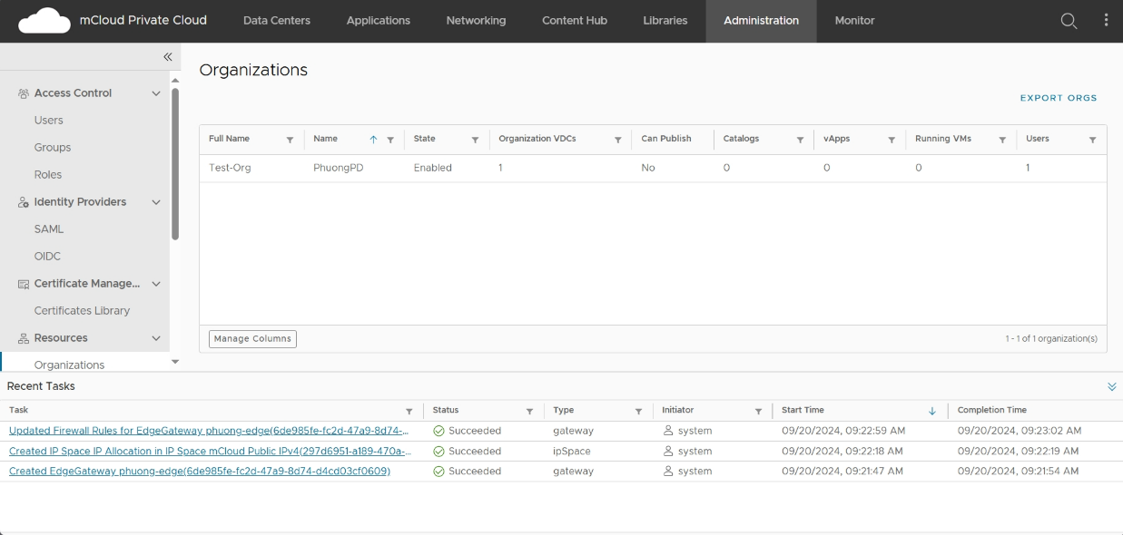

## Check status information

After successfully logging in, from the main administration screen, customers can view the general parameters in the virtual Datacenter: **Site**, **vApp**, **VM**, **allocated resources**, **used resources**, etc.

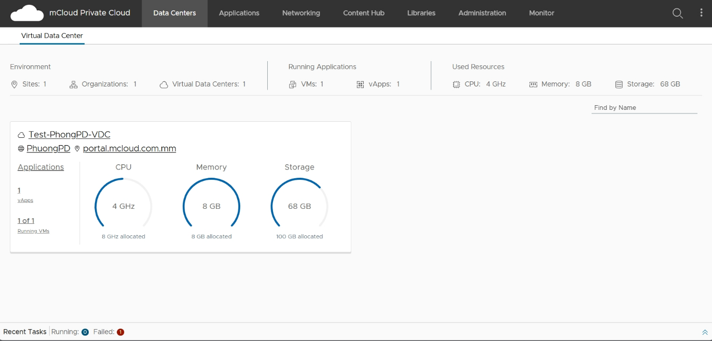 Click on Customer Datacenter and to view information about available virtual servers. You can select the search icon and enter the name of the machine to quickly find the server.

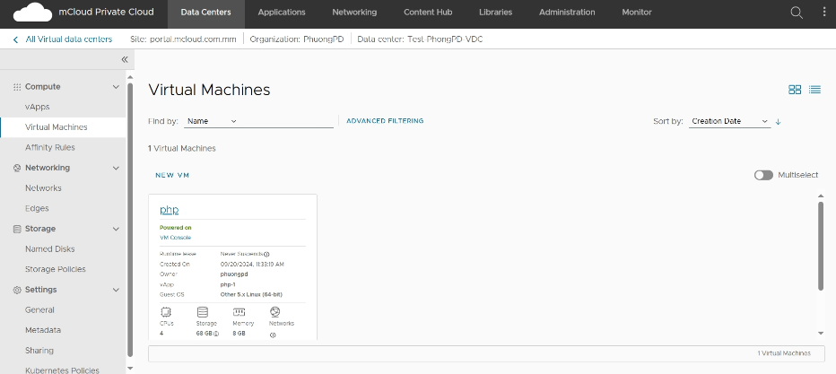

To view the details of the VM: Name, OS in use, status of the server, information about RAM hardware, CPU (Compute), HDD, network, etc. tap on the corresponding VM:

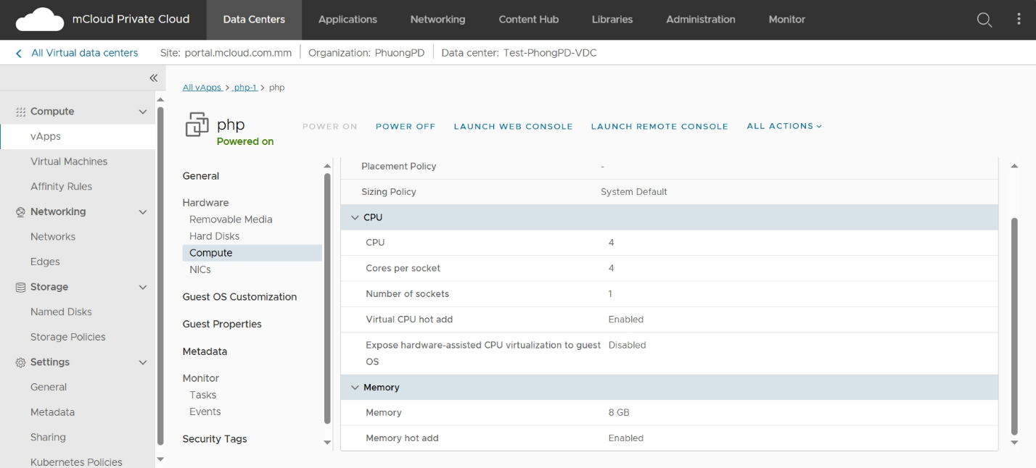

✍ To view the vApp information and list, select **the vApp** in the **Compute menu**  on the left:

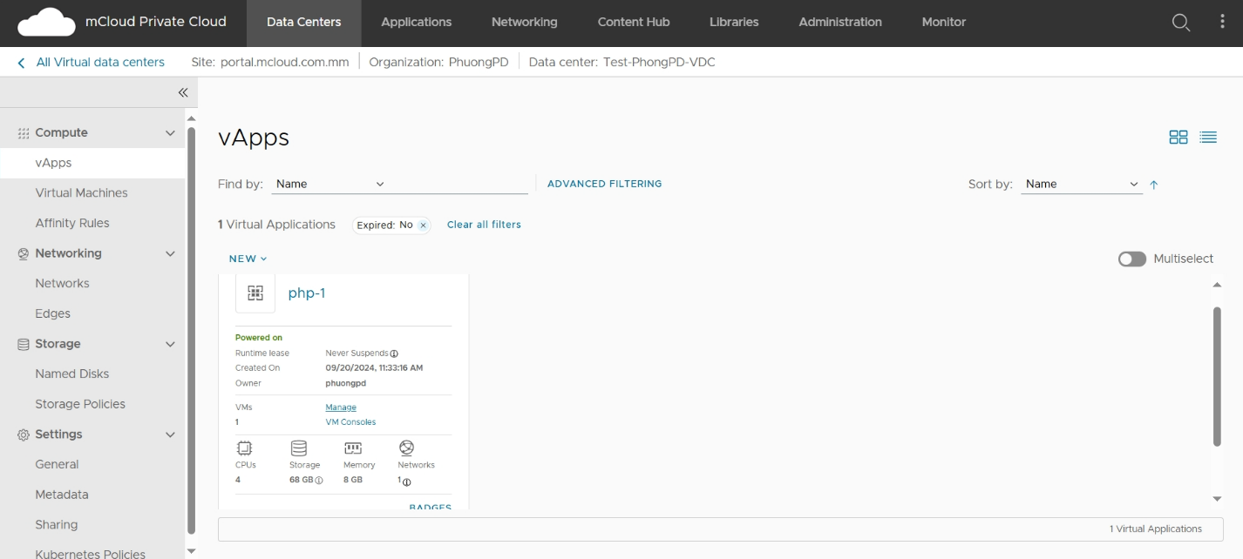

Check the list and status of the networks:

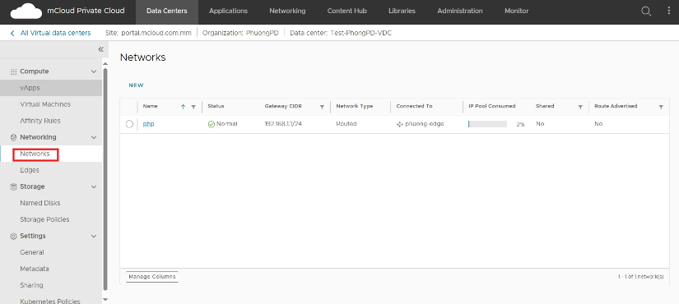

Check the Edge Gateway status (in case the Guest has rented vFirewall or vLoad Balancer services):

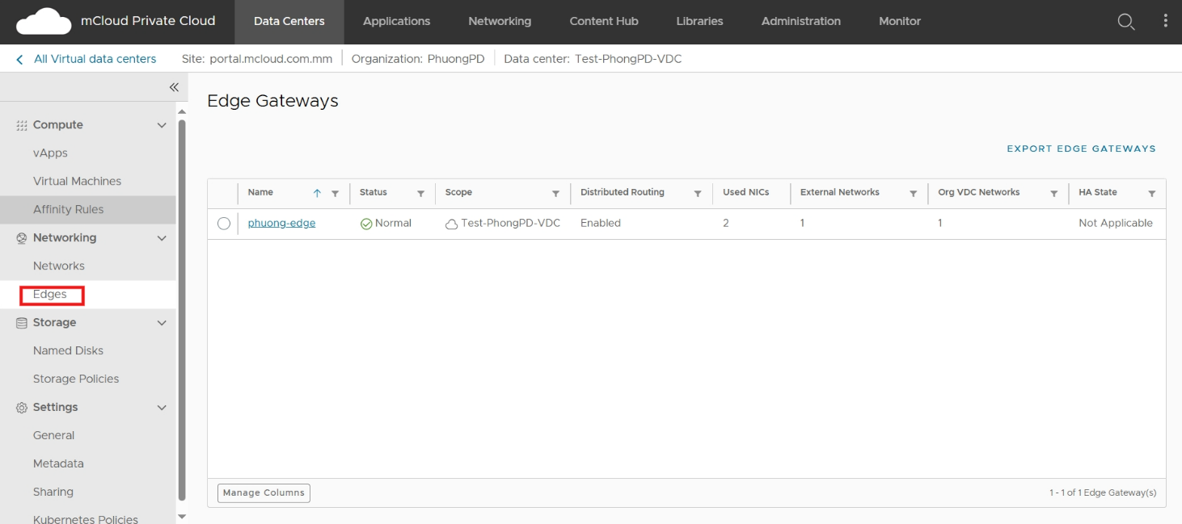

## Operation on a virtual server

On the home screen, select the Virtual Machines menu, select the VM you want to work with, and press the **Actions button**.

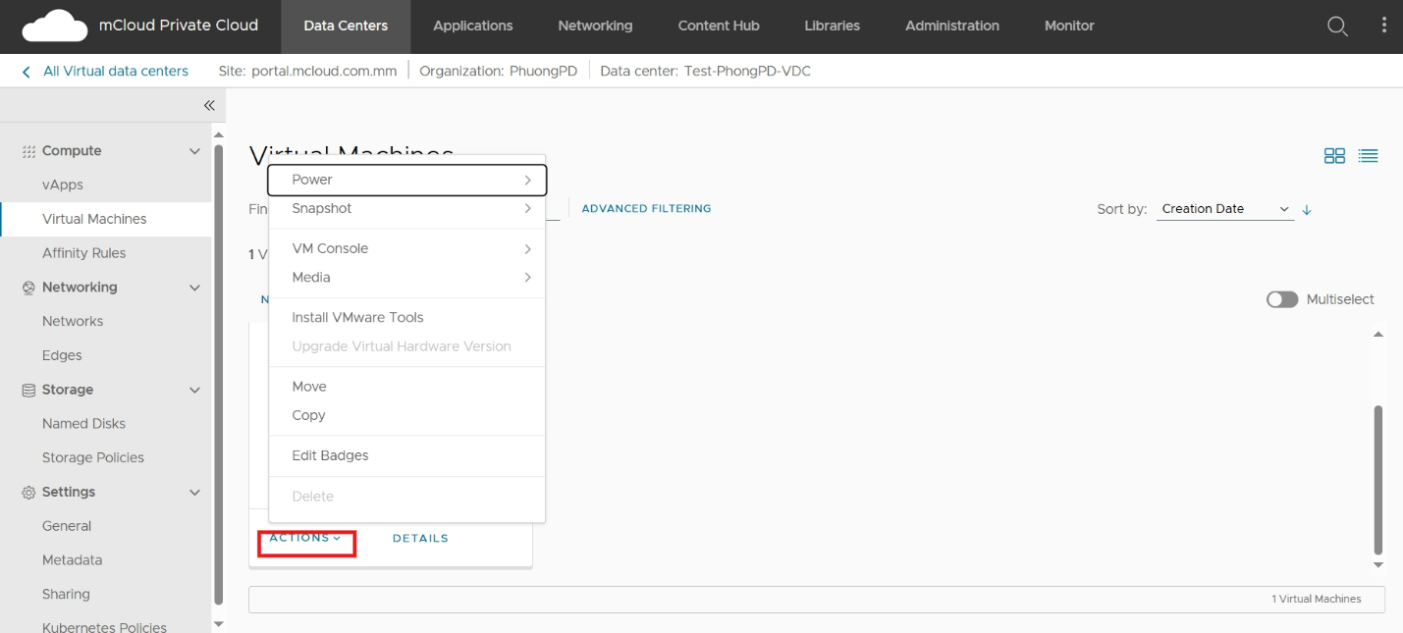

It includes the following main operations:

* Power on: reopen the server (which was in the previous power off state).
* Power on and Force Recustomization: open the machine and automatically execute Guest Customize properties for the Operating System (computer name, change SID, admin password,...). This parameter is configured in the Guest OS Customization section of the VM (select the Details button).
* Power off: turn off the server.
* Shutdown Guest OS: invokes the operating system shutdown command (requires Vmware tools).
* Reset: resets the virtual server's hardening of the server.
* Suspend: suspend the server (similar to sleep on Windows)
* Copy To: Clone (clone) VM. The VM must be in the Power off state and not contain a snapshot.
* Move To: move VMs to another vApp
* Launch Web console: console to VM using a web browser
* Create Snapshot: create a snapshot (save only 1 snapshot). Customer

need to purchase additional storage space (total equal to HDD space + RAM space-space to save swap files). Note: it is recommended not to save snapshots for too long (>3 days). If there is a need for a long-term backup version, you can use the Backup service.

* Revert to Snapshot: restores a previously created snapshot.
* Remove Snapshot: Deletes a previously created snapshot.
* Insert media: insert the ISO file to install the Operating System, boot disk.
* Eject media: release the previously inserted ISO file.
* Install Vmware Tools: start the Vmware tool installation mode. The system will automatically insert the installation file into the media drives inside the Operating System.

Customers need to enter the console and follow the instructions.

mCloud has a library of ISO files to install operating systems and popular applications/appliances (SQL Server, Pfsense, Sophos...), utilities (Hiren Boot, Gparted CD, etc.). You can filter by Name field for a faster search, and please refer to the "Guide to Manually Reinstalling the Operating System for Servers from vCloud Portal".

**Note**: *In case you reinstall the Operating System for the Virtual Server by yourself, please install the Vmware Tool or Open-VM-Tools application to ensure that the compatibility, performance, and features on the system are stable.*

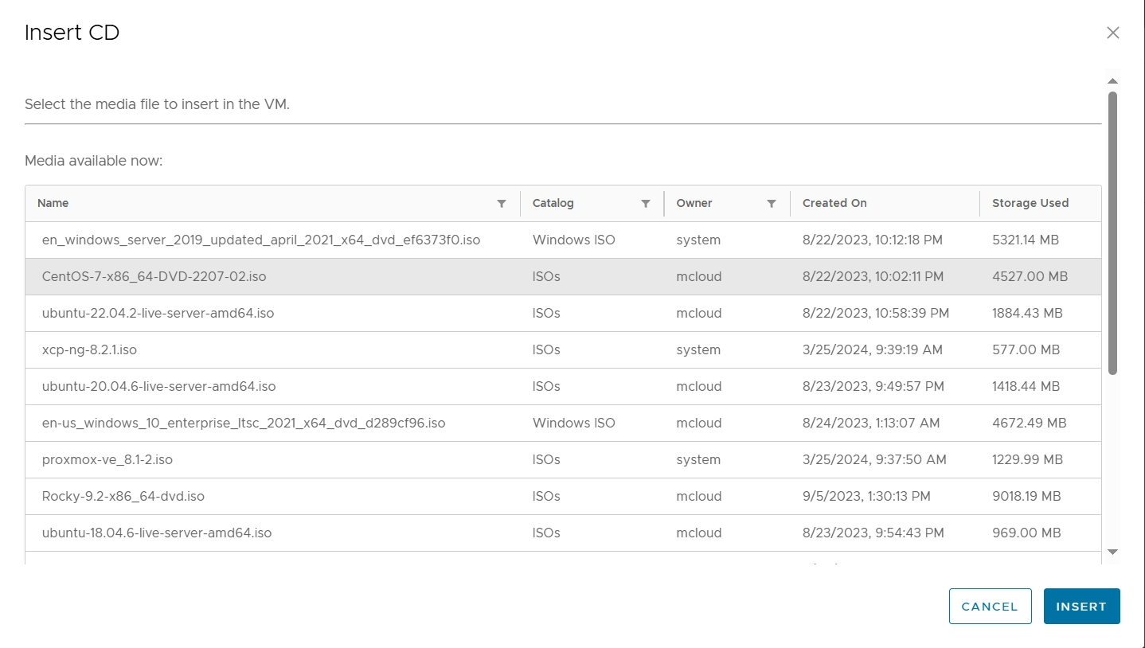

## Console

Customers can console directly to the screen of the virtual server through the

browse the Web or VM Remote Console (VMware Remote ConsoleVMRC application needs to be installed on the client machine).

* Launch Web Console: console to the server screen via the Web Console interface.
* Launch VM Remote Console: Access the server using the VM Remote Console.
* Download VMRC: Download the VMware Remote Console widget.

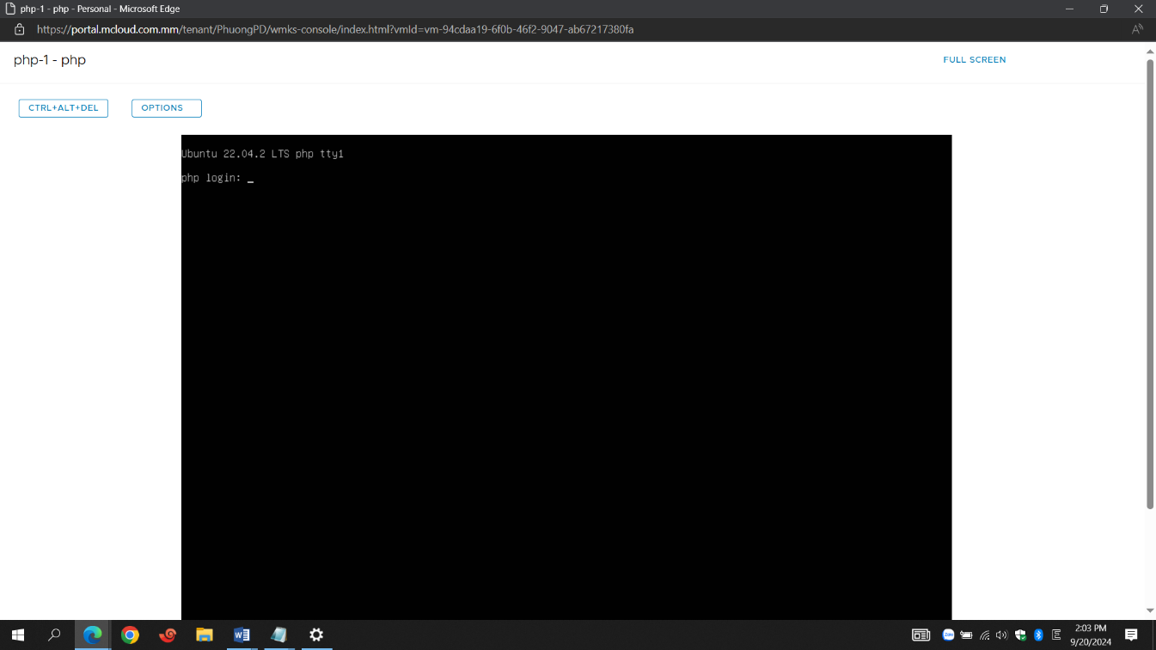

## Snapshot

In the event that storage space is rented for Snapshot, the Customer may use this function to create snapshots for the server. Note: the system hosts a single snapshot, creating a new snapshot will overwrite the old snapshot.

* Create Snapshot: tạo bản Snapshot
* Revert to Snapshot: Restores a previously created Snapshot.

- Remove Snapshot: Deletes the snapshot.

## User Management Guide

To add/remove/edit users logging in to your vCloud Portal, from the admin interface, select **the Administration -> Users menu**

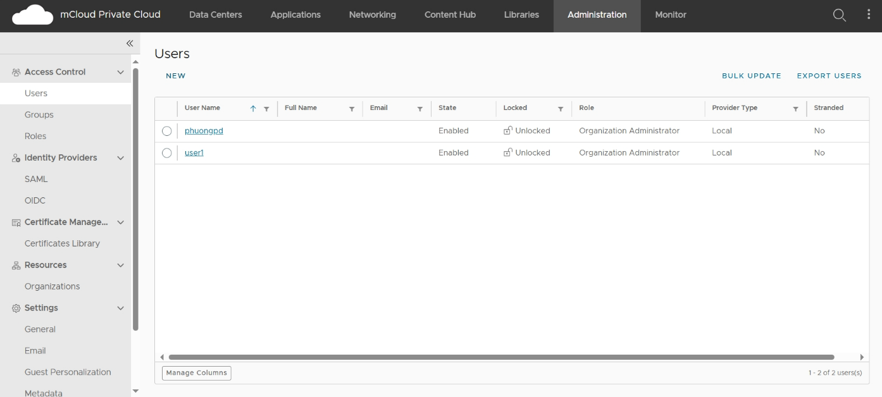

To create a new User, select the **New button**:

* Enter your name and password in the Username, Password and personal information boxes in the Contact Info section.
* Select Permissions in the Role section. Usually the highest permission is selected: **Organization Administrator**.

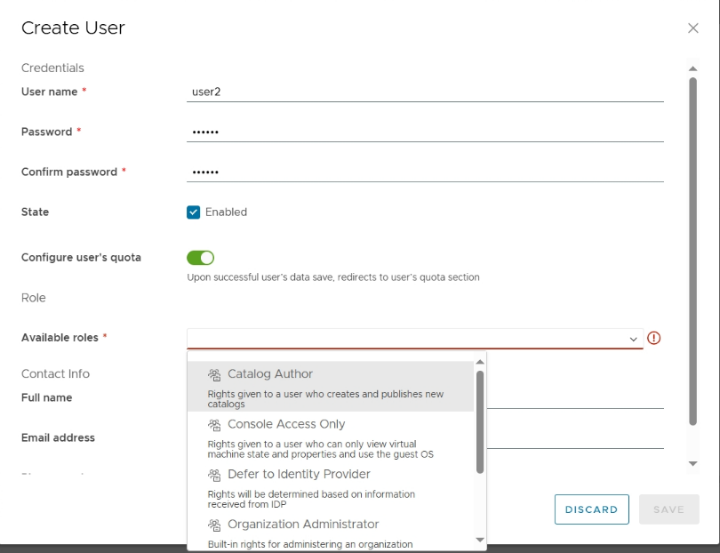

* Select Unlimited in the Quotas section



Finally, click **Save** to save the changes.

To edit select the **Edit** button and select **Disable-Delete** accordingly.

## Instructions for resetting the admin password of the Operating System

To perform this operation, the Operating System of the Virtual Host needs to be installed with the Vmware tools application on Windows or the Open-vm-tools package in Linux operating systems.

At the same time, only the following popular Operating Systems are compatible with this Guest customization feature:

* Windows Server 2008 R2, 2012 R2, 2016, 2019
* CentOS/ Red Hat Enterprise Linux 6.x -> 8.x
* Ubuntu 14.04, 16.04, 18.04 ,20.04,22.04

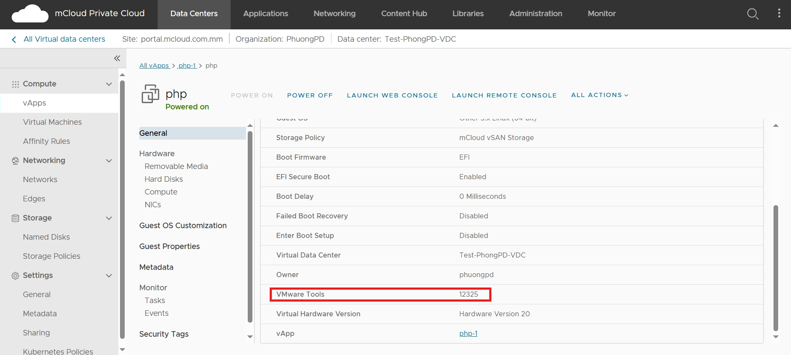

**Step 1:** From the VM administration screen, select **the Guest OS Customization -> Edit tab**  to perform a password reset for the Administrator/Root user **Step 2:**

* **Enable guest customization**: Allow parameter changes inside the Operating System, which needs to be selected for the features below to take effect.
* **Allow local administrator password**: Change the login password of the user administrator.
* Select **Require Administrator to change password on first login** if you want to change the admin password the first login.
* Enter the new password in the **Specify password** box

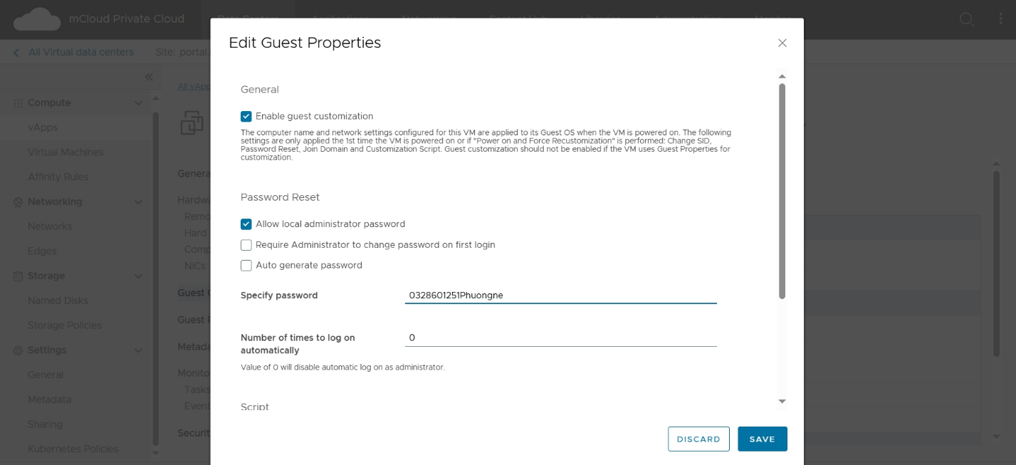

The actions below will take effect the first time the Server is opened or when the administrator clicks Power **on and force recustomization**. To enforce the changes, it is necessary to power off the VM then use the **Power on and force recustomization** command. Or simply, customers can do it automatically through the "Change password" feature on the Automation Service Portal interface.

## Check the impact event on the system

Used when customers need to check for issues, events, and information that directly impacts the server system.

Go to the **Monitor** Tab – **Task** and **Events**

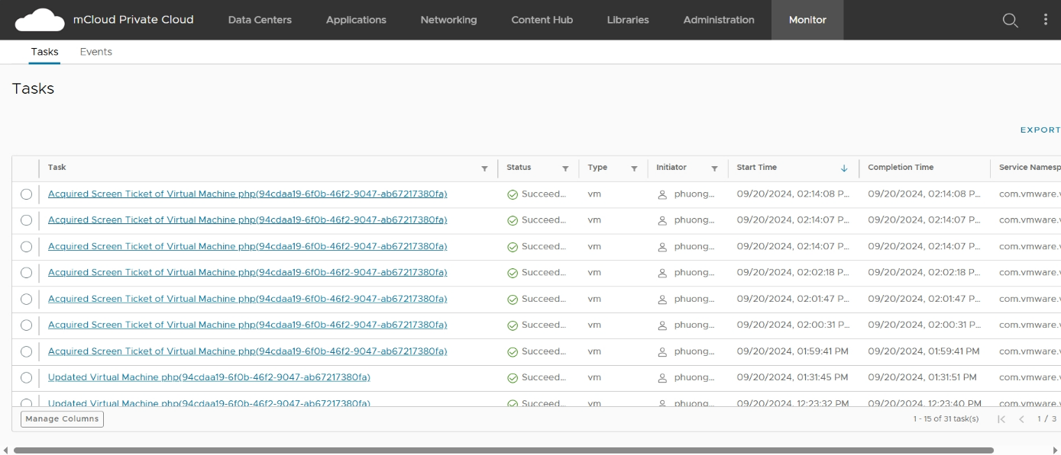

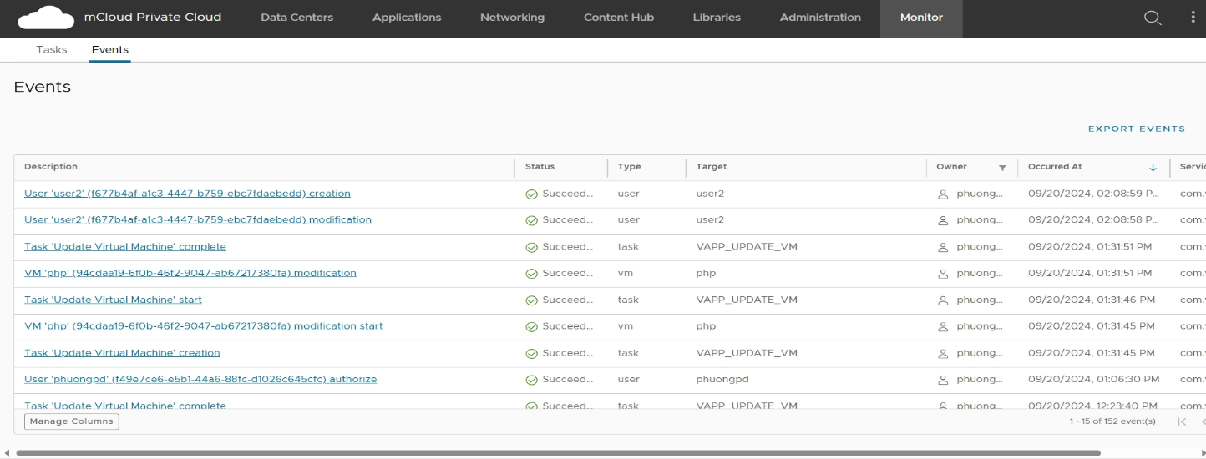

# Operation management on the VCD system

## Create a virtual server (new VM)

- Clone VM from Template

At the VDC administration, click **Data Centers=>Virtual Data Center =>Select Data Center=> Virtual Machines**. Select Add **New VM**:

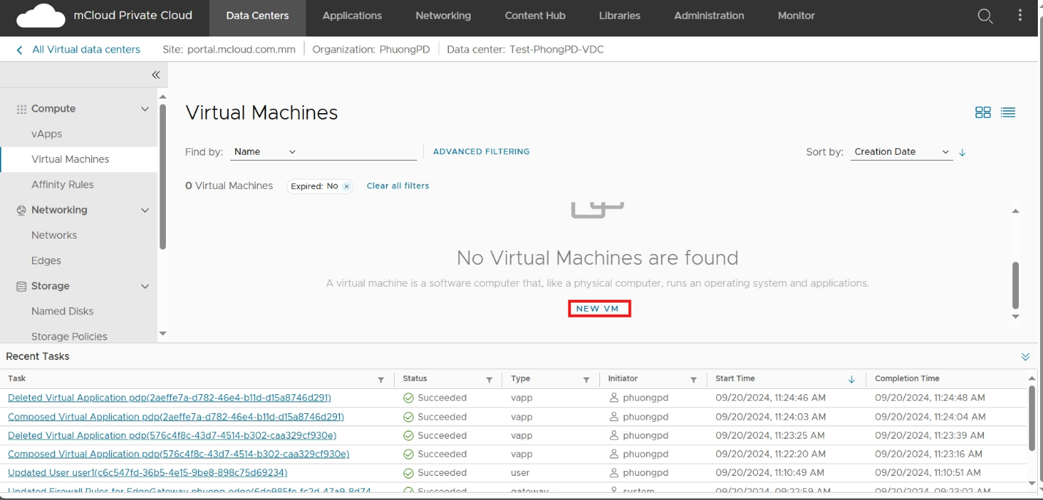

Then you can type the computer name,select new type or from template(select template) and click in to connected box.Click Ok to finish.

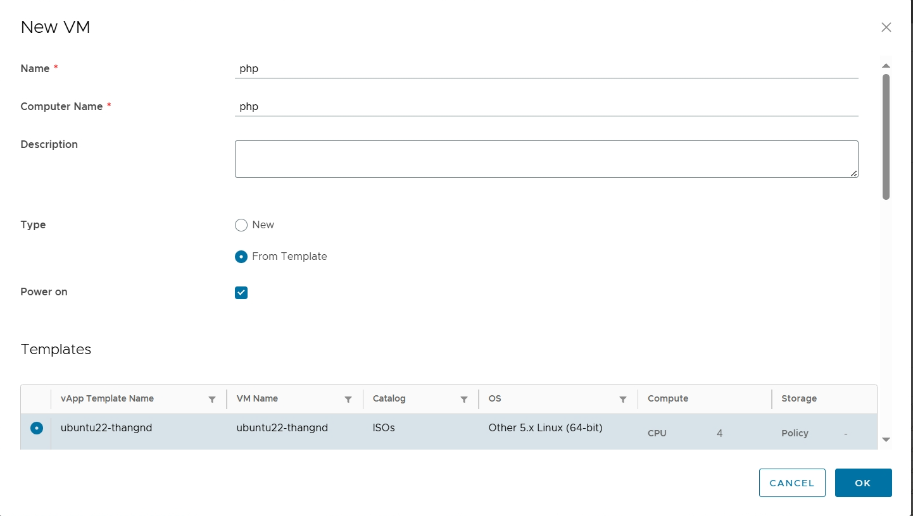

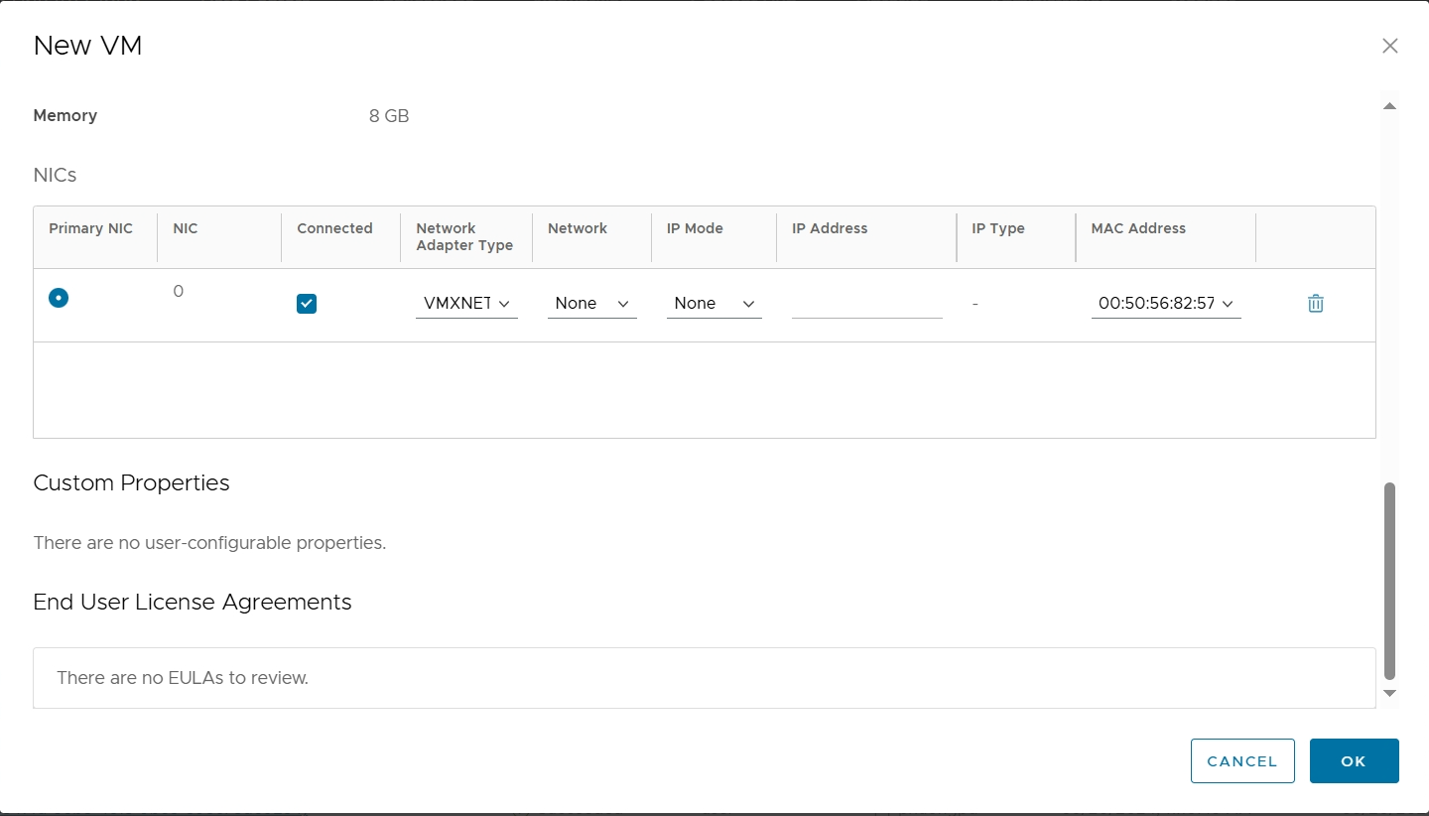

If the Org already has at least 1 vApp:

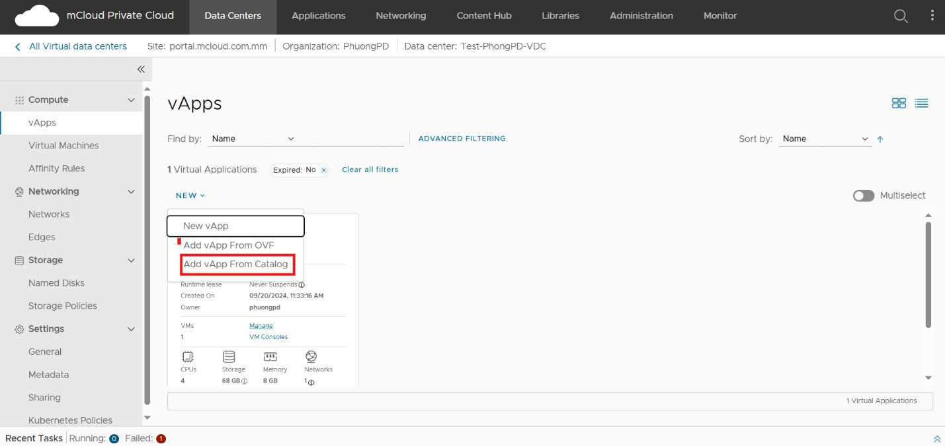

Select the Template to be imported in the List and click **Next**

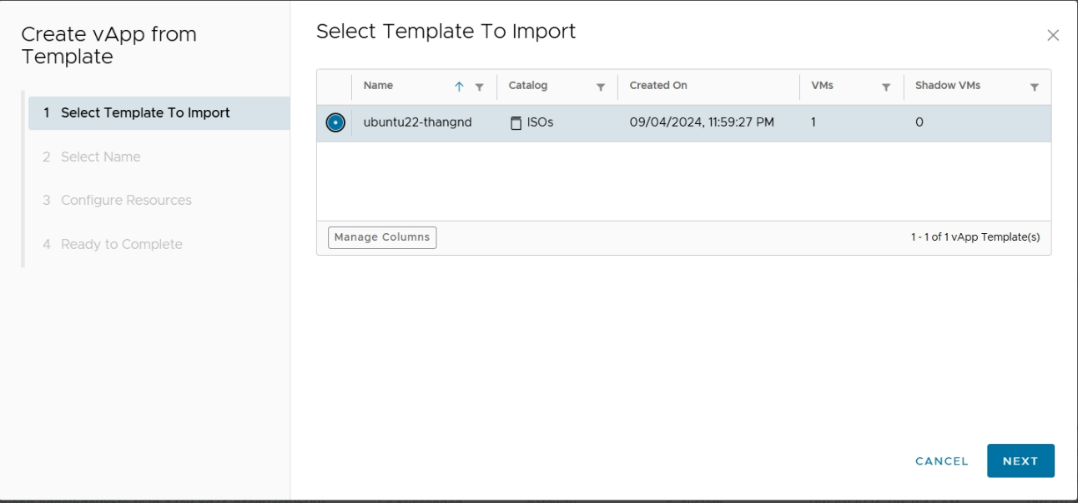

Fill in the name for the vApp according to the standard: Customer Code-xx (where xx is the ordinal number of the vApp). If there are no special requirements, the default 1vApp will contain 1VM. Parameter

**Runtime lease and Storage lease** select **Never Expries**. Click **Next**

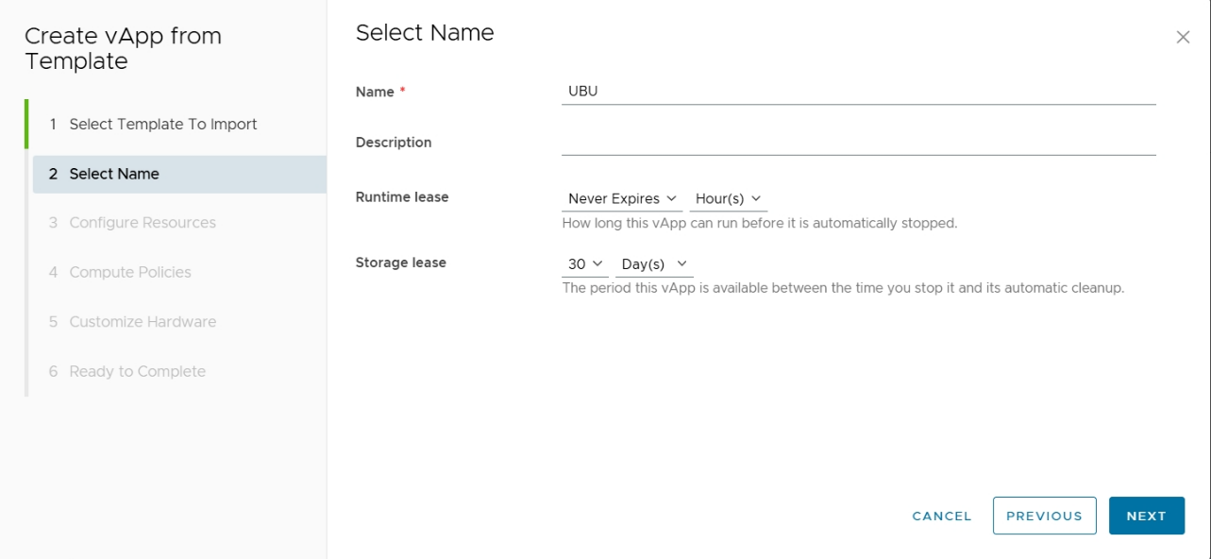

Give the VM a name for selecting the storage type. A regular VM name will be the same as the vApp name:

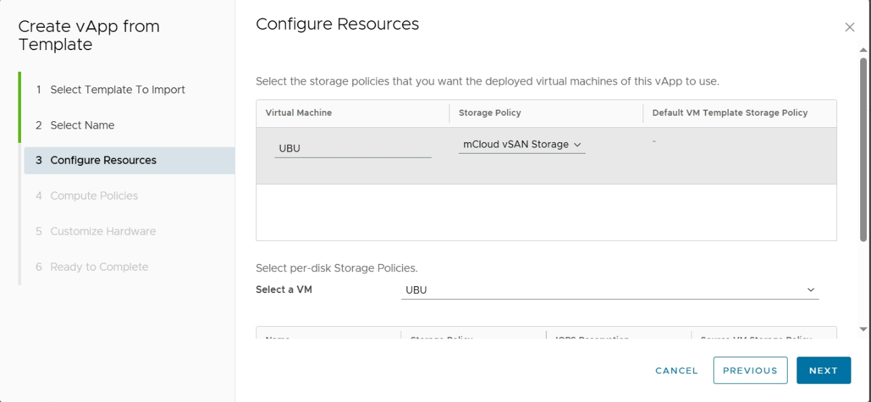

The **Compute Policies** section to default, the **Customize Hardware** section enters the required disk space for the VM:

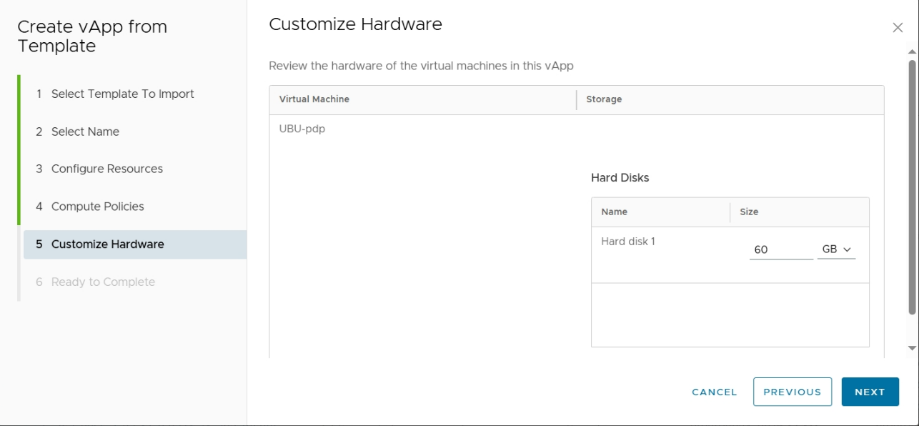

Select Ready to Complete and click **Finish**:

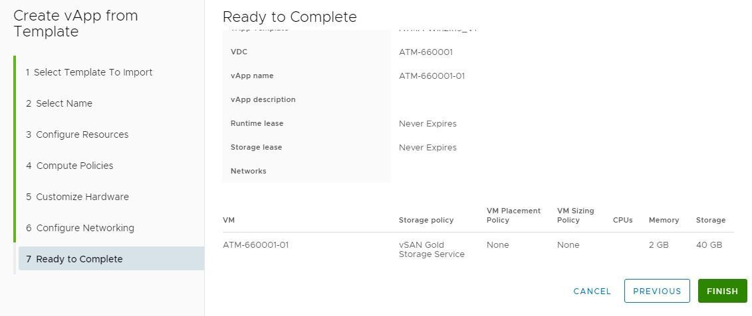

🖎 Create **an Org VDC Network**. In case you have already created an Org VDC Network for the required IP range, you can skip this step.

Go to the **Data Centers=>Virtual Data Center=>Select Data Center=> Networks=>New.**

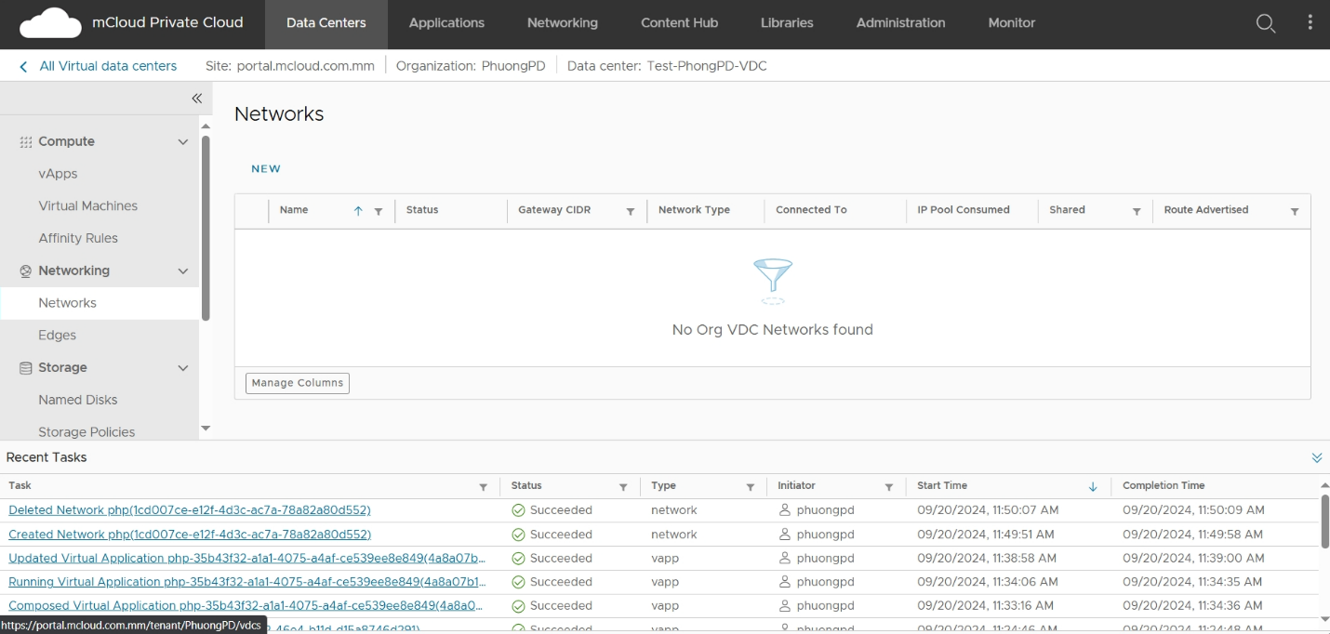

Select a style connection, select Edge connection(if rented vFireWall and VLoadBalance), Gateway CIDR the IP/VLAN range to be granted to the client, and click **Next.**

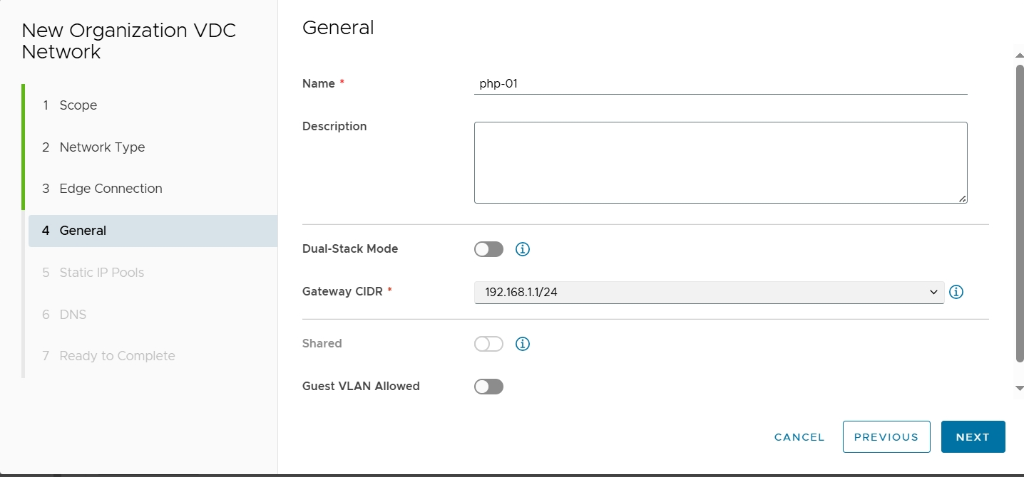

Fill in the name for **Org VDC Networks** according to the standard: Client Code-xx (where xx is the order number of the Network).

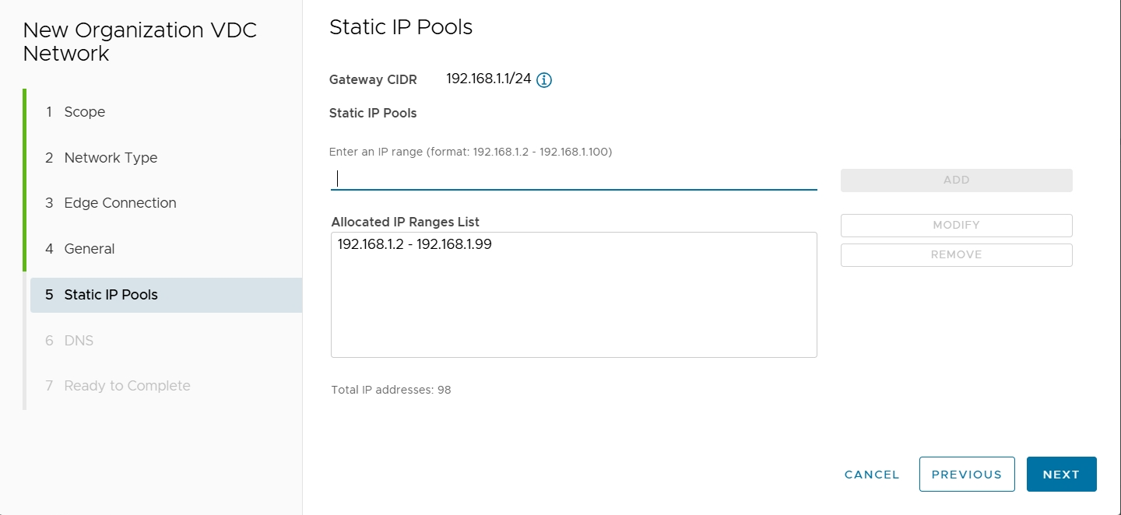

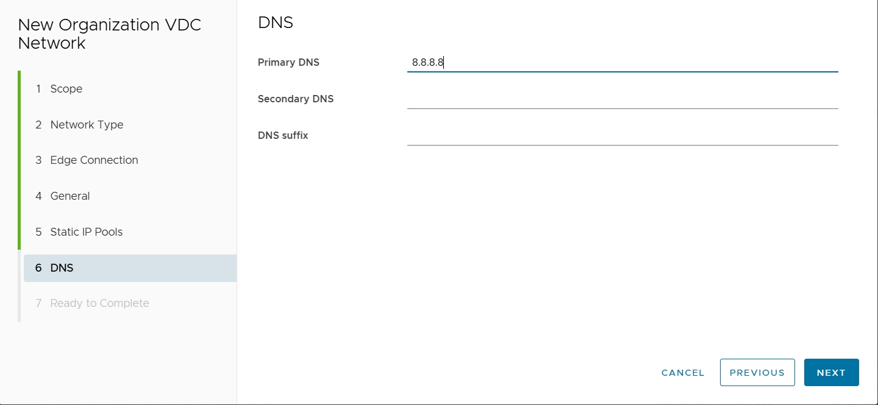

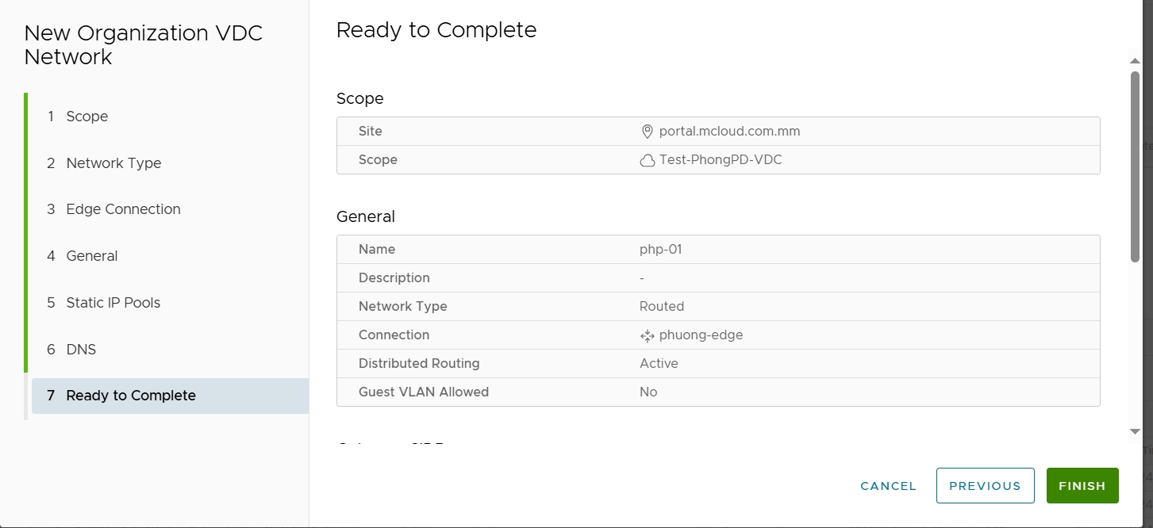 Click **Finish** to initialize.

🖎 Switch to **the Virtual Machine section** in the Left Panel. The panel should display the virtual machines that are in the VDC. Click on the newly initialized VM:

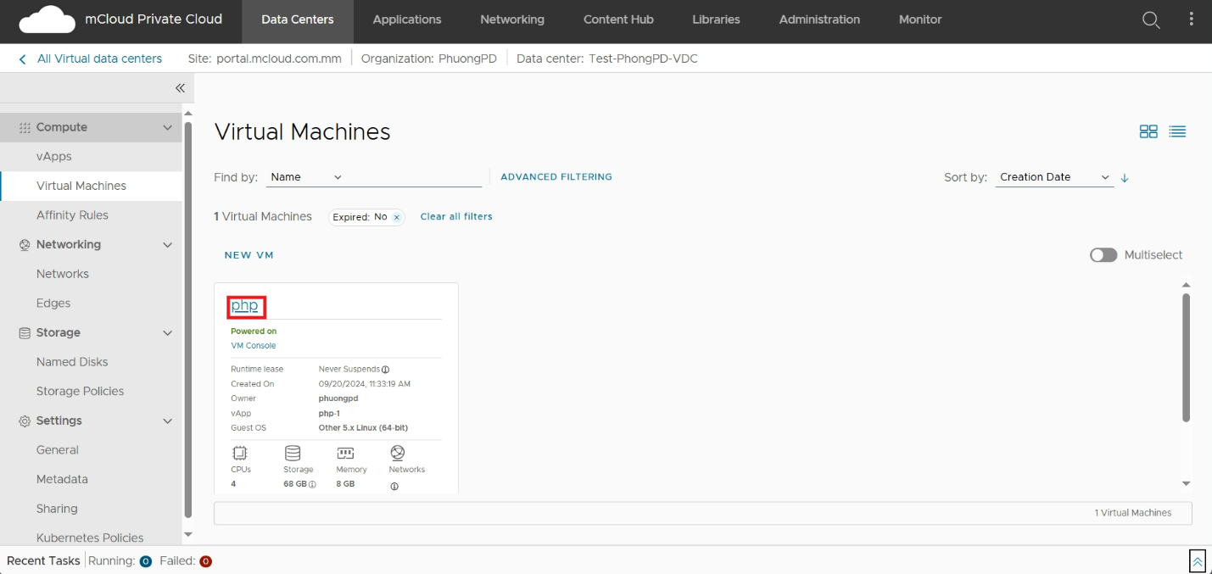

In the **Hardware tab**  , click **Edit** to reset the number  **of vCPUs** and **RAM** to match the configuration of the tenant in the **Compute** section and the disk capacity in the **Storage section**

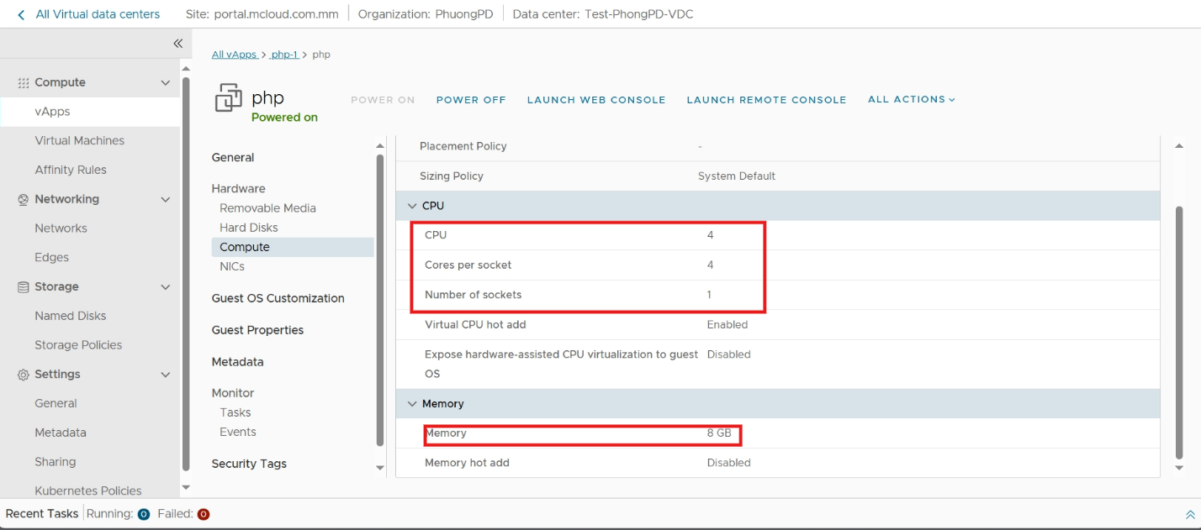

Note: 2 Virtual **CPU hot add** and **Memory hot add** parameters must be **in the Enable state**

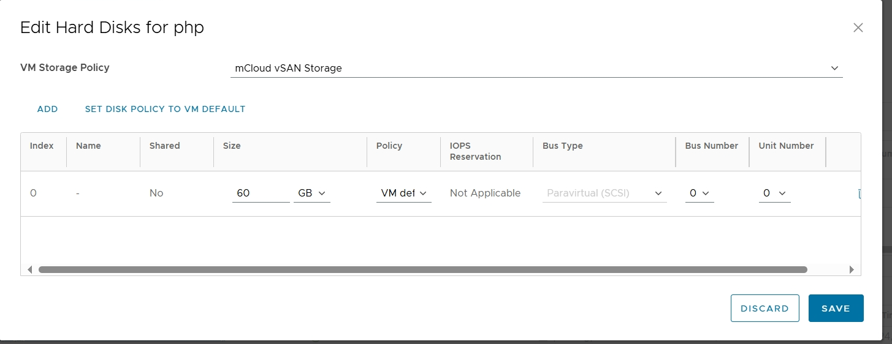

In the **NICs section**, select **Edit** and **Add Network, select Type OrgVDC Network**, and click on the newly created network above. Click **Add**

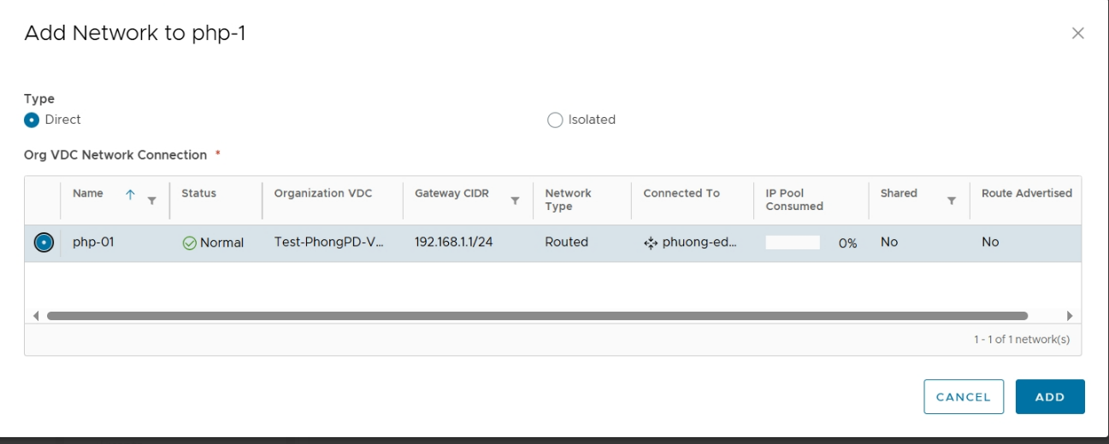

Return to the network card creation screen, click New and select the parameters:

* **Adapter type**: select **VMXNET3**
* **Network** select Org VDC Network created - **IP mode** select **Static – IP Pool** fill in the IP level selected for that VM Click **Save** to save the configuration.

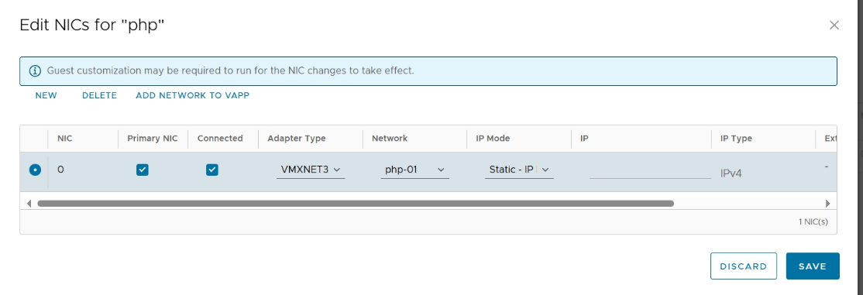

After initialization, review the configuration parameters of the VM in 1 turn and proceed to Power on VM; check the network status, Operating System of the VM.

## Edit the configuration of the VM (vCPU, RAM, HDD)

Client accesses the Client's VDC under the account provided.

After entering the management page of VDC, click on **the Data Centers – Virtual Machines** section, click on the **VM** to edit the configuration:

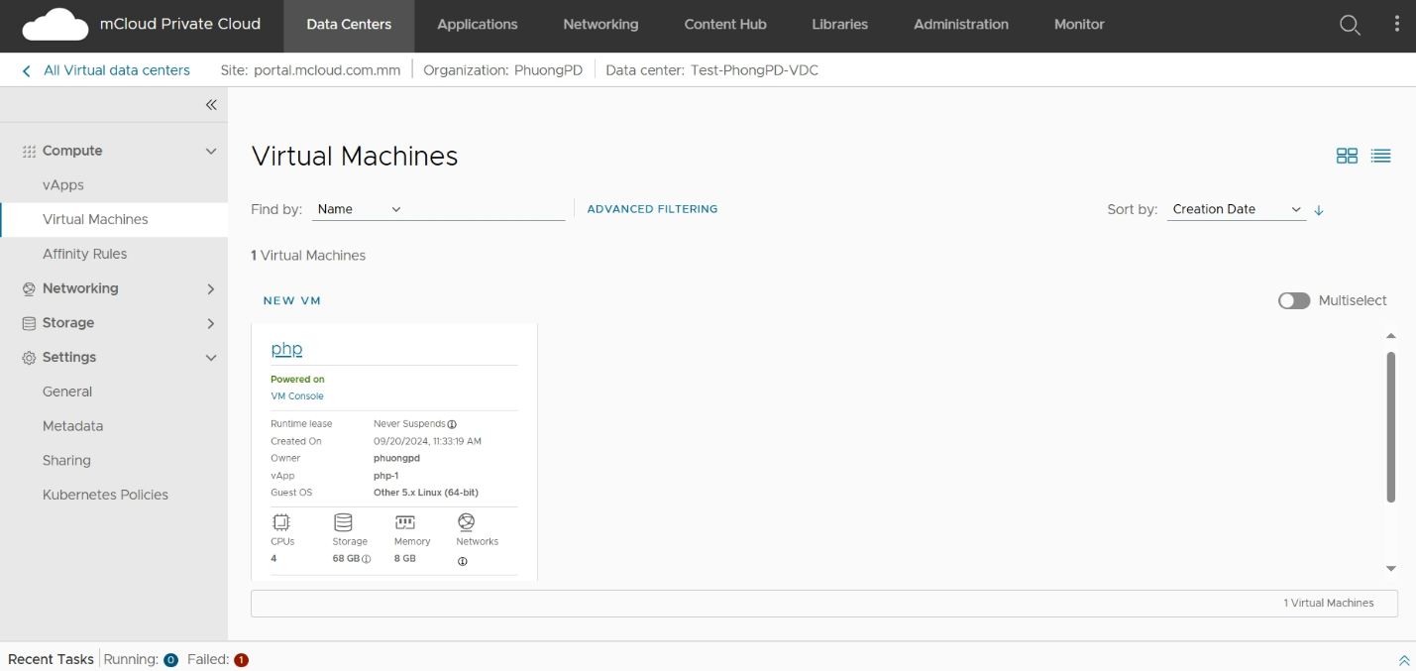

* **For vCPU, RAM**: In the properties window, switch to **the Hardware - Compute** tab and click **Edit** to edit the corresponding vCPU and RAM configurations as needed. Click **Save** to save the information.

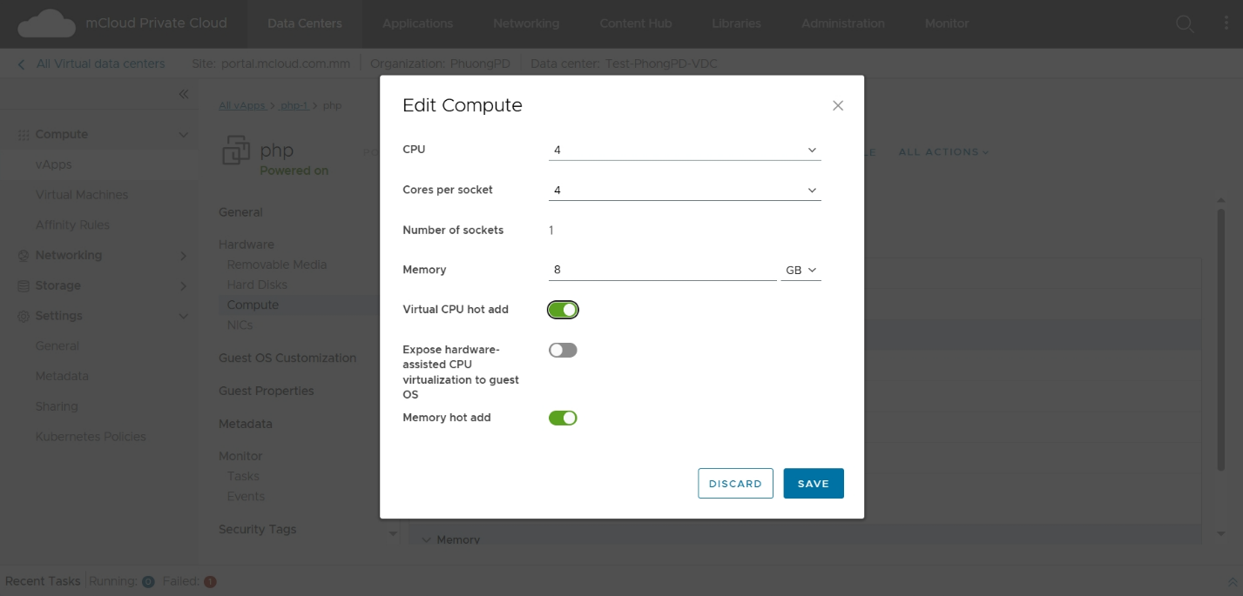

* **For disks**: In the Properties window, switch to the **Hardware – Hard disks** tab and **Edit** to increase the required hard drive space. Click **Save** to save the information.

Note: there are 2 ways to expand an existing volume or create a new volume. To expand an existing volume, the VM must not contain any snapshots. We need to choose the right method, usually to lift the existing drive.

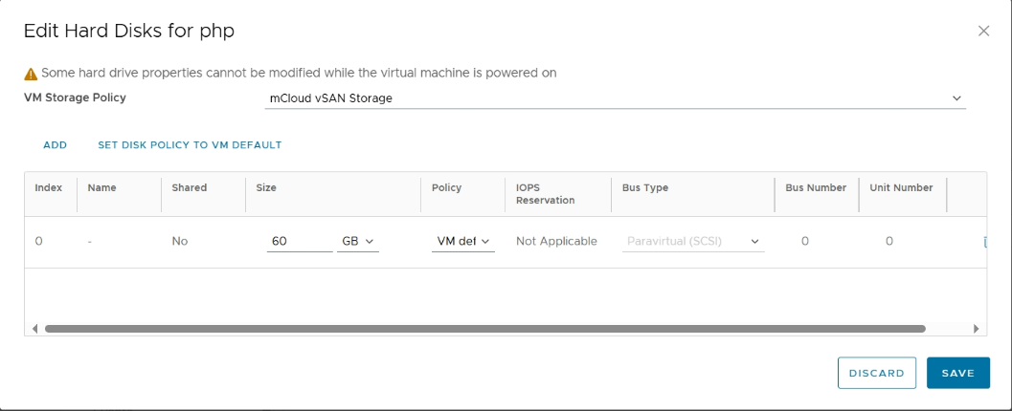

## Server Restart Instructions

The reset function on the VCD admin page is also a server reset function when the server crashes or has a problem. In addition to the usual way to access the server and perform a reset, we can also reset by going to the VCD admin page and performing a server reset.

Go to **Datacenters** => select **Datacenter**=>select **Virtual Machines** section=> select the Virtual Machines need to Restart,**Actions**,**Power**,**Reset**.

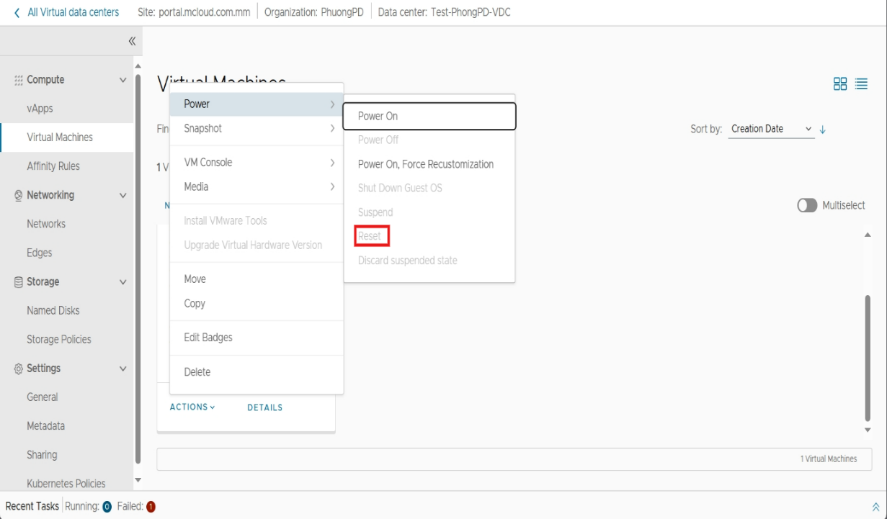

## Instructions for shutting down the server

In addition to performing Power Off (aka Shutdown server) in the operating system.

You can also use the Power Off function to perform a server shutdown.

Go to **Datacenters** – select **Datacenter**=>select **Virtual Machines** section=> select the Virtual Machines need to shutdown,**Actions**,**Power**,**Poweroff**.

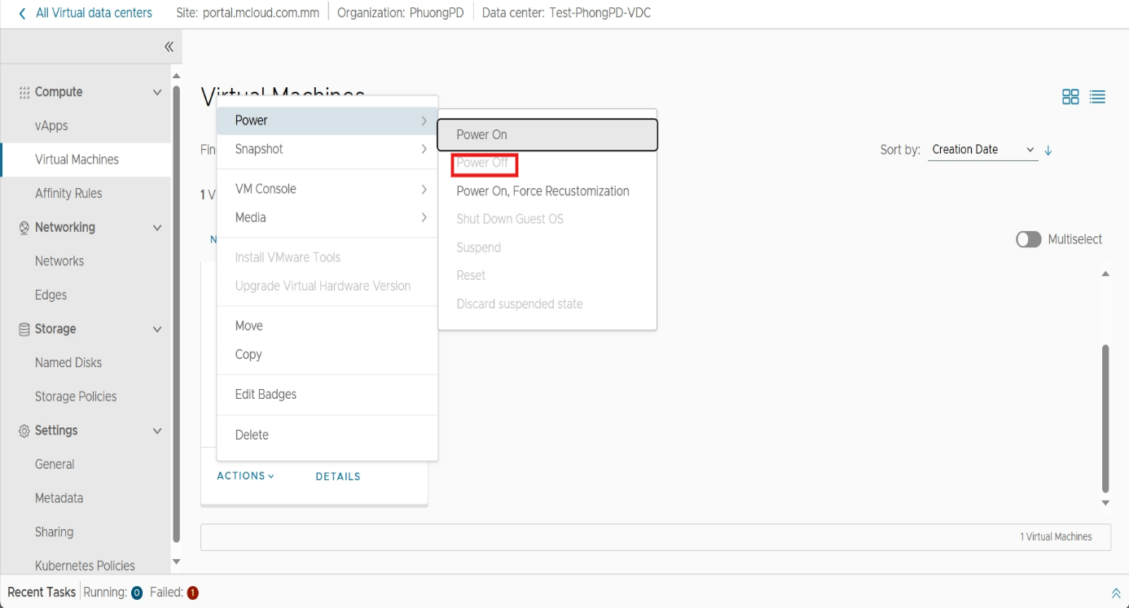

***Note: In addition to shutting down the server with Power Off, you can still use Shut Down Guest OS.***

## Server pause instructions

Suspend is a function to suspend a service. This function can be compared to Sleep in windows. When resuming a VM, the state before the suspend will be kept in the state before the pause.

Go to **Datacenters** – select **Datacenter**=>select **Virtual Machines** section=> select the Virtual Machines need to pause,**Actions**,**Power**,**Suspend**.

Note: After Suspend, if you want to resume the server, do the following:

Go to **Datacenters** – select **Datacenter**=>select **Virtual Machines** section=> select the Virtual Machines need to resume,**Actions**,**Power**,**Suspend**

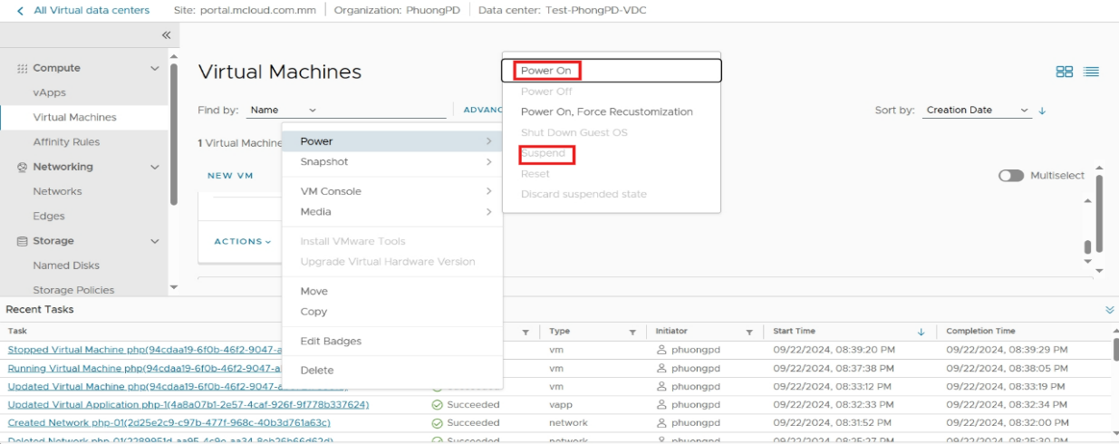

## How to delete a server

First you need to turn off Vm machine.

When the VM's machine status is Powered off.

Go to **Datacenters** – select **Datacenter**=>select **Virtual Machines** section=> select the Virtual Machines need to delete,**Actions**,**Power**,**Delete**.

The system will delete the VM (Note: The server will be permanently deleted and cannot be recovered)

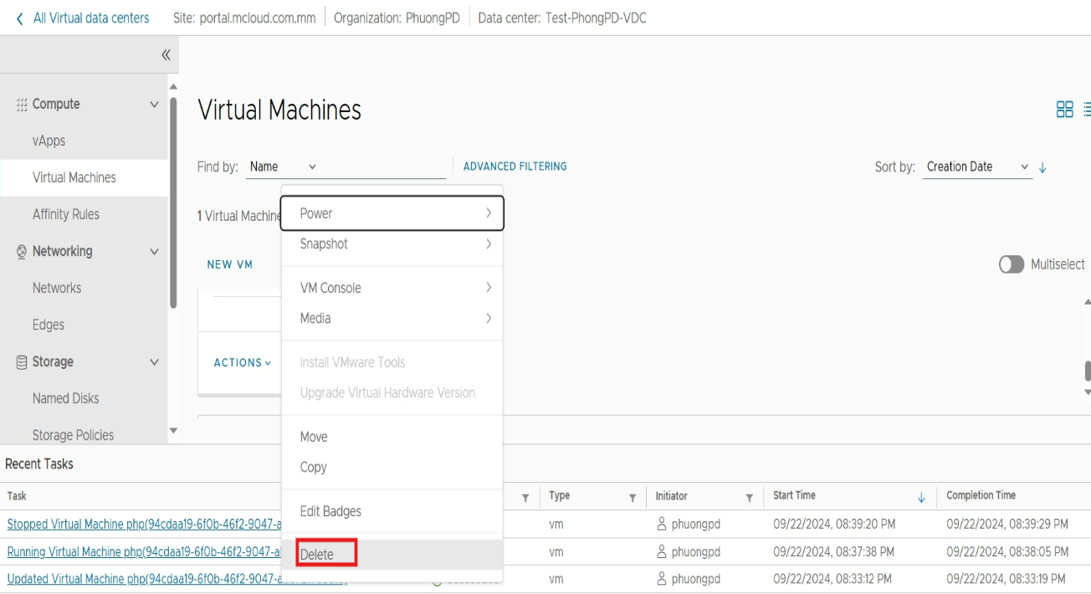

# vFirewall, vLoad Balancer Service Configuration Guide

vFirewall and vLoad Balancer are 2 add-ons based on the VMWare solution provided on mCloud's VMware Cloud Director service platform.

Let's say we need to set up a baseline-level network model as shown below:

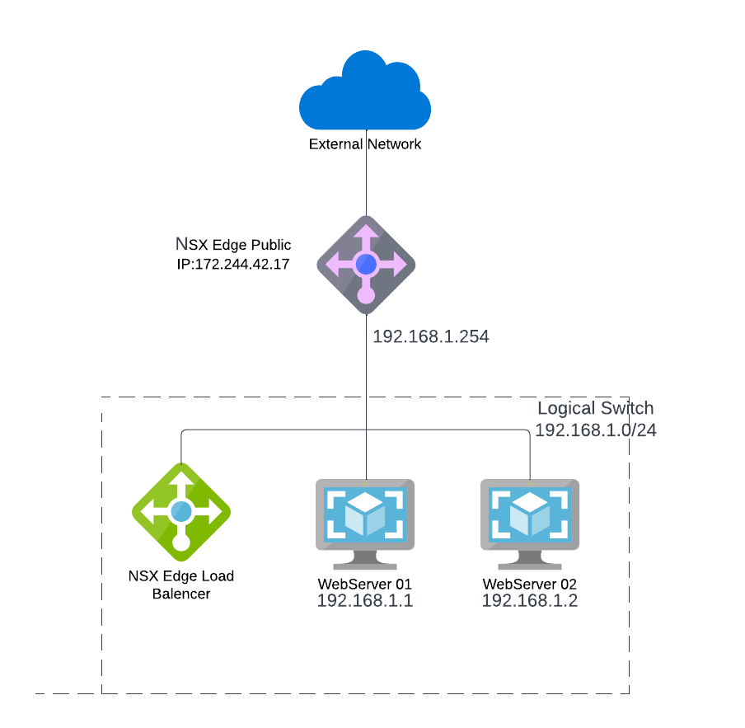

|  | Private Zone | Public Zone | Fashion |
| --- | --- | --- | --- |
| NSX Edge  (vFirewall) | 192.168.1.254 | 171.244.42.17 | There is a direct interface with the internet |
| NSX Edge Load Balancer | 1 cluster of 2 members Web Server  below | 171.244.42.17 | VIP represents the cluster |
| Web Server 01 | 192.168.1.1 | 171.244.42.111 | NAT via vFirewall |
| Web Server 02 | 192.168.1.2 | 171.244.42.112 | NAT via vFirewall |

In this model, we can see that there are 2 types of Public IPs: 1 is the IP used to represent the NSX Edge, (vFirewall), as a virtual IP for vLoad Balancer (temporarily called Master IP); 2 is the public IPs used for 1:1 NAT for VMs (temporarily called NAT IPs).

## Configure Network Address Translation (NAT)

From the Admin screen in Org VDC Clients, click **Data Center => Networking**

**=> Edges=>NAT**.

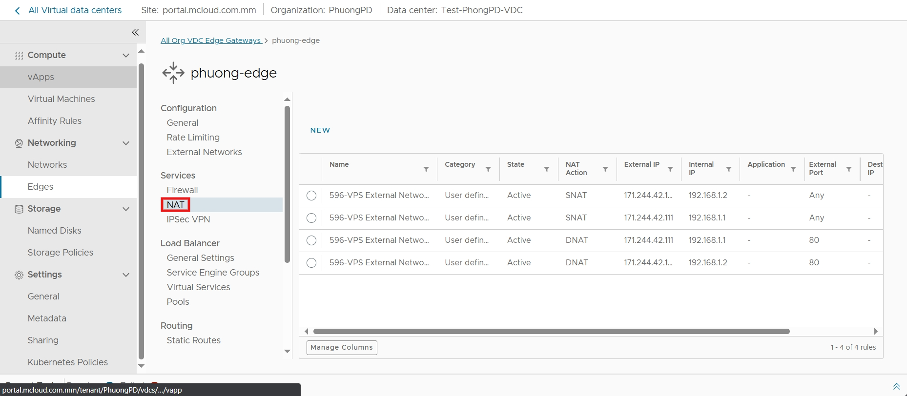

Switch to **the NAT** tab, which will display a list of all configured NAT Rules. mCloud's vFirewall solution supports 2 main types of NAT: NAT by source

(SNAT) and targeted NAT (DNAT) for both IPv4 and IPv6. This tutorial focuses on IPv4.

To create a new NAT rule, select the **New** that corresponds to the NAT form you want to create:

* **SNAT** 
  + **NAT action**: Select SNAT
  + **Internal IP**: enter the original IP (private IP of the server)
  + **External IP**: The IP that is converted after NAT (i.e. the Public

NAT IP obtained above)

* + **Description**: enter a description

Click **Save** after filling in the parameters.

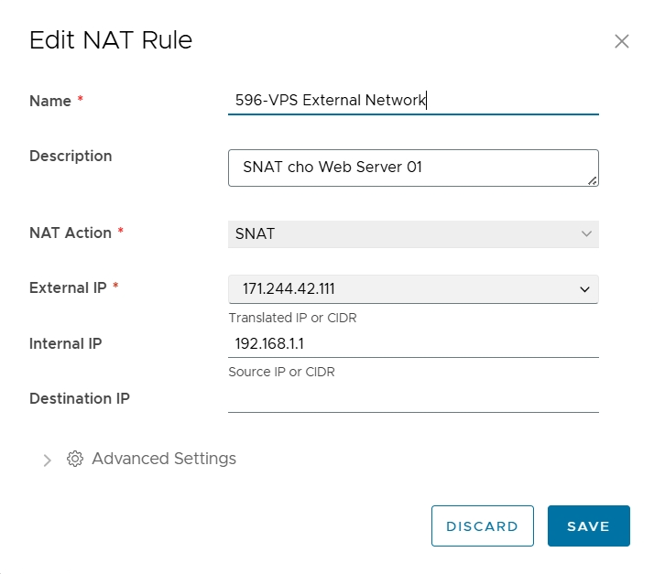

* **DNAT** 
  + NAT Action: Select DNAT
  + **Internal IP:** enter the original IP (Public IP, which is the Public NAT IP obtained above)
  + **External Port:Choose port**
  + **Description**: enter a description
  + **External IP:** The server's private IP is converted after NAT
  + **Translated Port:** Choose a app

Click **Save** after filling in the parameters

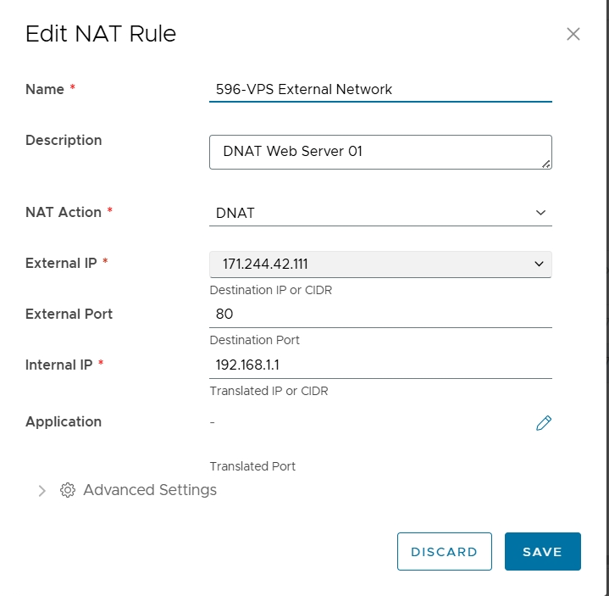

Do the same for Web Server 02 We have this

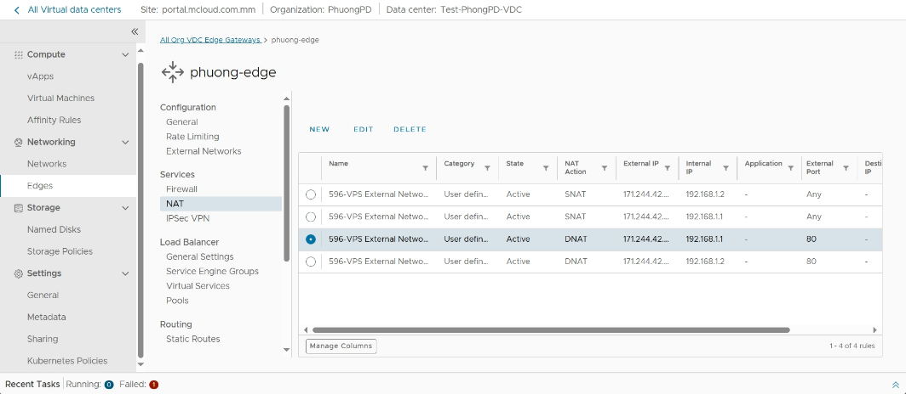

✍ To make adjustments to the declared NAT rule, select the corresponding NAT rule and press EDIT section. Similarly, to delete a rule, select the DELETE section.

## Declaring Firewall Rules

Switch to the Firewall tab, making sure Firewall is enabled

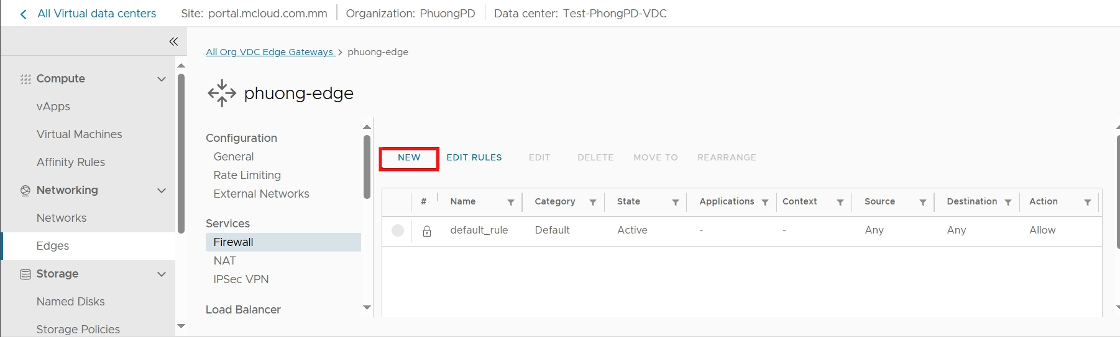How to create a new rule

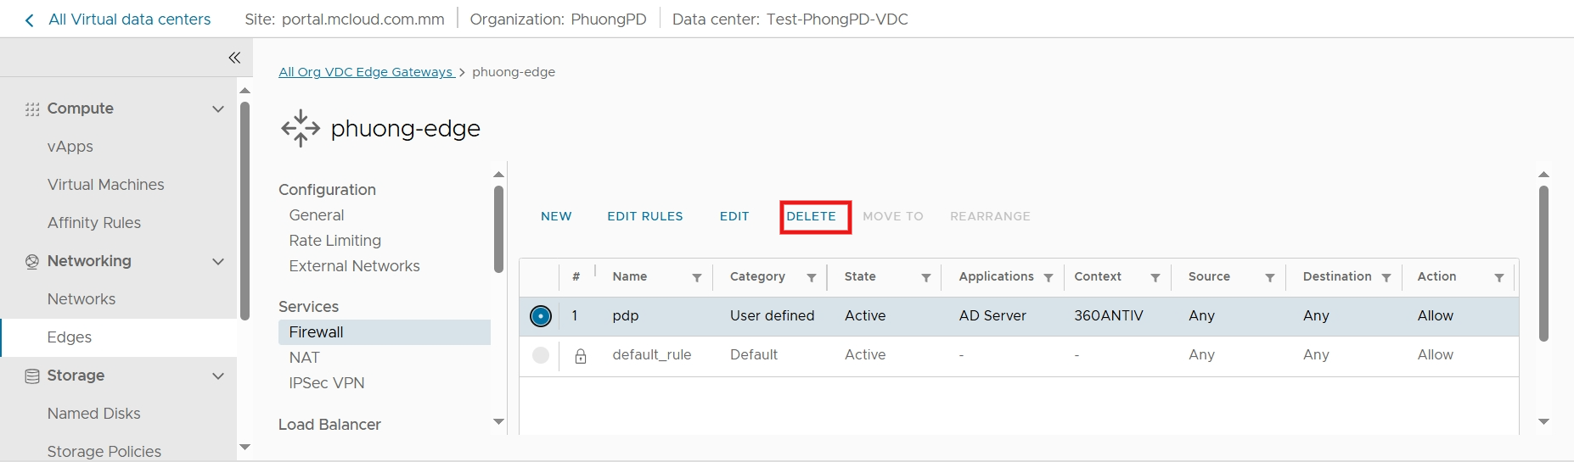How to delete the selected rule

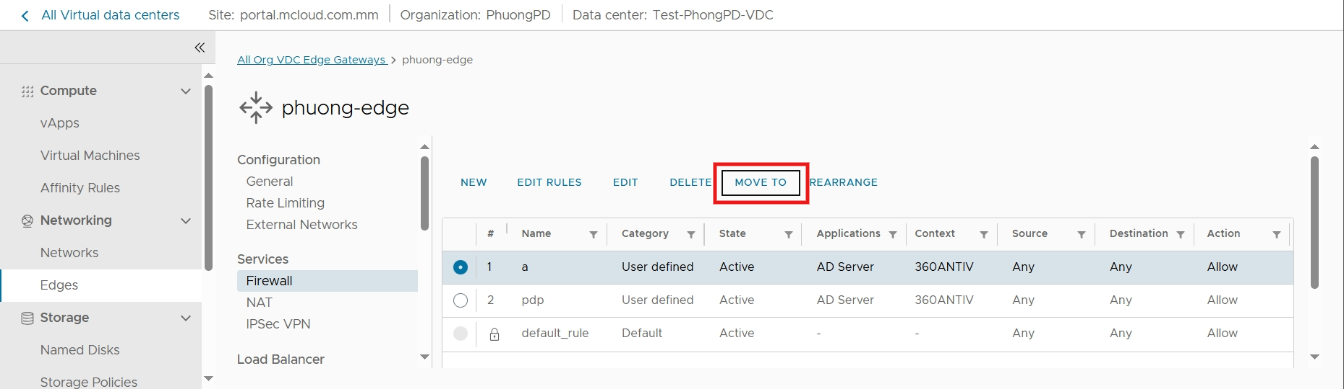 Move the priority of the rule to another level

**Note:You can use rearrange to move the priority too but easier**

After clicking on the create new rule, the admin window will create new lines , click on the corresponding box to edit the required information:

* **Name**: the name of the rule
* **State:** Turn on or off
* **Applications**: Applications and their ports
* **Context**:Network context profiles
* **Source**: the source IP address, which can be tapped ADD to enter the IP **- Destination**: the destination IP address.
* **Action:** choose the type of action: **Allow** or **Drop or Reject**

After completing the rules as desired, press the "**Save**" button to save and execute the new configuration.

🕮 **Illustrative example for the original simulation system model:**



**Meaning**:

* + Rule No.3: Allow traffic from the internal network (192.168.1.x) to all destinations (including the external network). The internal network will follow the NAT rules declared above to access the Internet
  + Rules 1 and 2: Allow the client to be able to ping (ICMP) and access the web service (http-tcp port 80) of the 2 public IPs 171.244.42.111 and 171.244.42.112. This is the NAT IP of 2 Web servers 192.168.1.1 and 192.168.1.2. Combined with rules NAT above,clients from external networks(internet) can access the web to 2 server.Traffic that does not match the above 3 rules is blocked by defaul .

✍ Check the results:

From Web Server 1, ping to the internet:

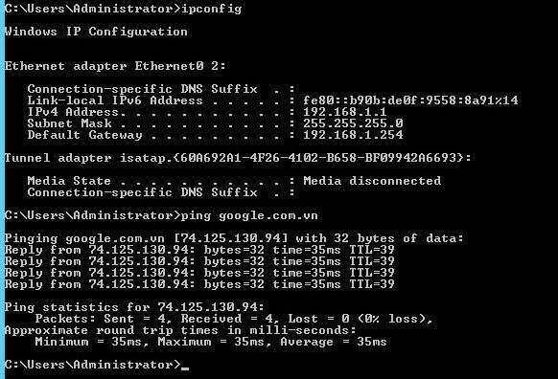



## IPsec VPN Site to Site Configuration

mCloud's vFirewall service package supports the Site-to-Site VPN connection declaration feature. From the Edges interface, select the **IPsec VPN** . Click select **NEW** to create a new VPN connection.



Then fill in the parameters to set up the VPN session as below. Note that these parameters must match the configuration on the remote router/firewall.

* **Status:** Turn on or off to allow or disable VPN session execution.
* **Enable perfect forward secrecy (PFS):** allows PFS mode to be run for added security (recommended).
* **Name**: the name of the VPN connection session
* **Authentication mode: a form of authentication, usually using a preshare key (PSK), or Certificate.**
* **Local Id**: Fill in the vFirewall's Public Master IP address. The simulated model case is 171.244.42.17
* **Network(Local Endpoint Networks)**: the private network range of the local end, in this case 192.168.1.0/24
* **Remote Endpoint IP:**The public IP of the remote router.
* **Remote Endpoint Network**: the private network strip of the far end.
* **Pre-Shared Key**: enter the preshared key

Select **Save** to apply the new VPN

You can also customize Security Profilein **Security Profile Customization**

* **Version**: Support 3 versions -IKE Flex-IKE v1-IKE v2
* **Digest**: Supports the following algorithms: SHA 1; SHA-256; SHA-384; SHA-512
* **Diffie-Hellman Group**: Group2,5,14,15,16,19,20,21
* **Association Life Time (seconds):**
* **Enable Perfect Forward Secrecy**

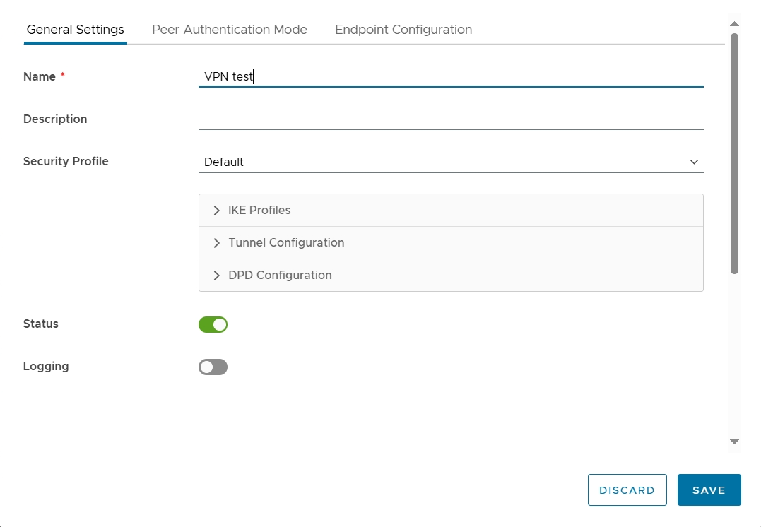

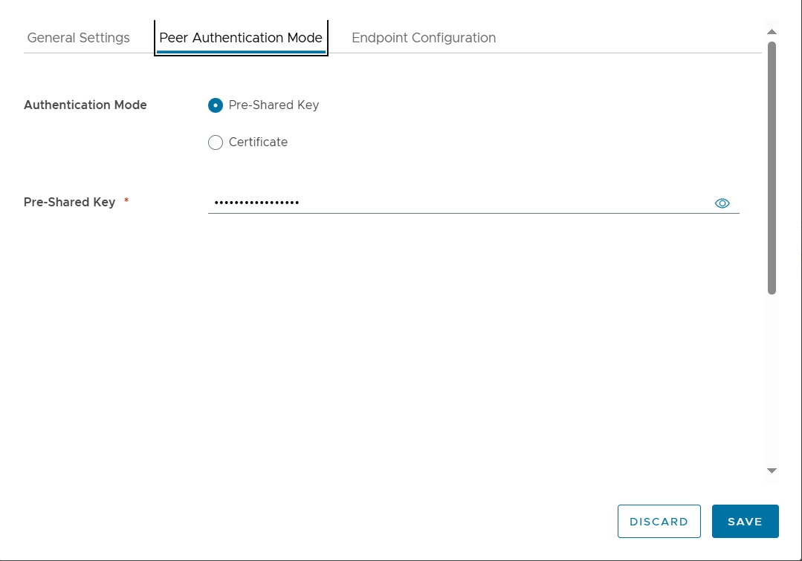

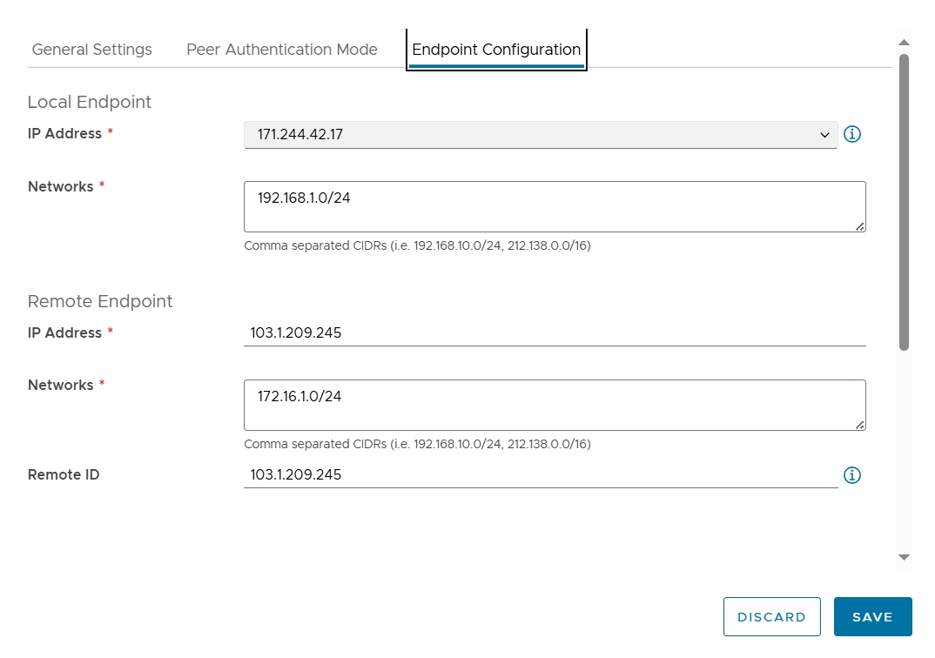

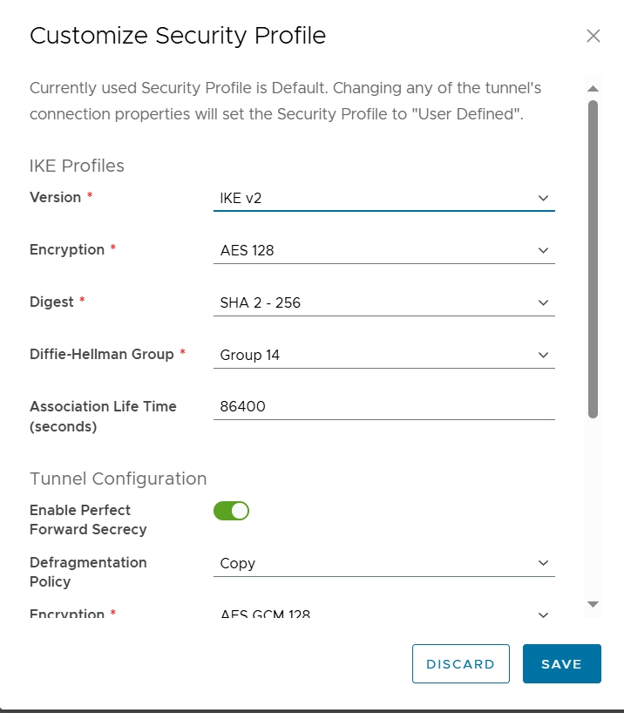

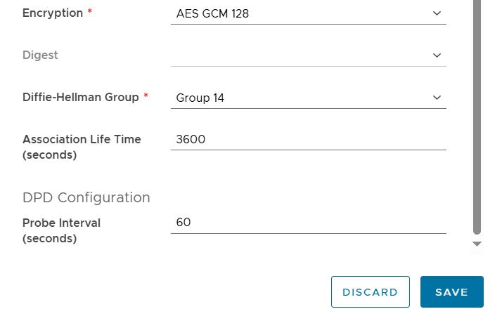

Click **SAVE** after filling in the parameters to apply the new changes.

🕮 **Let's say we need to set up a VPN connection channel according to the following model**:

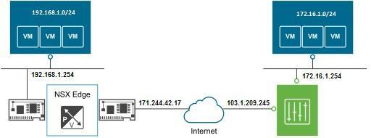

**Step 1**: Configure the Cloud end of mCloud as follows:

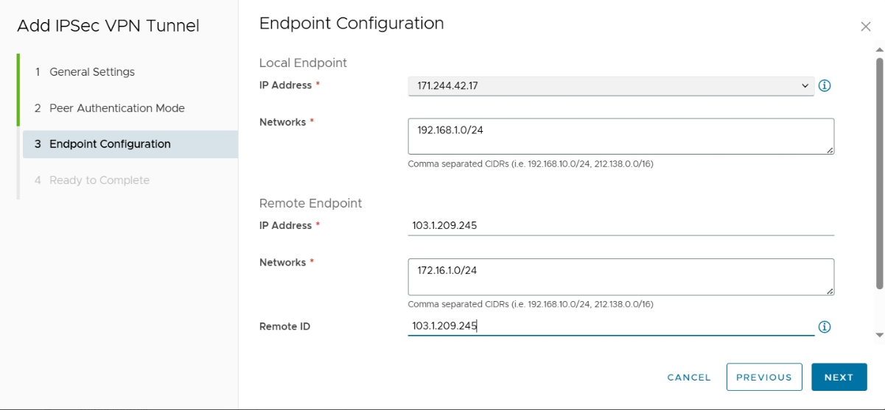

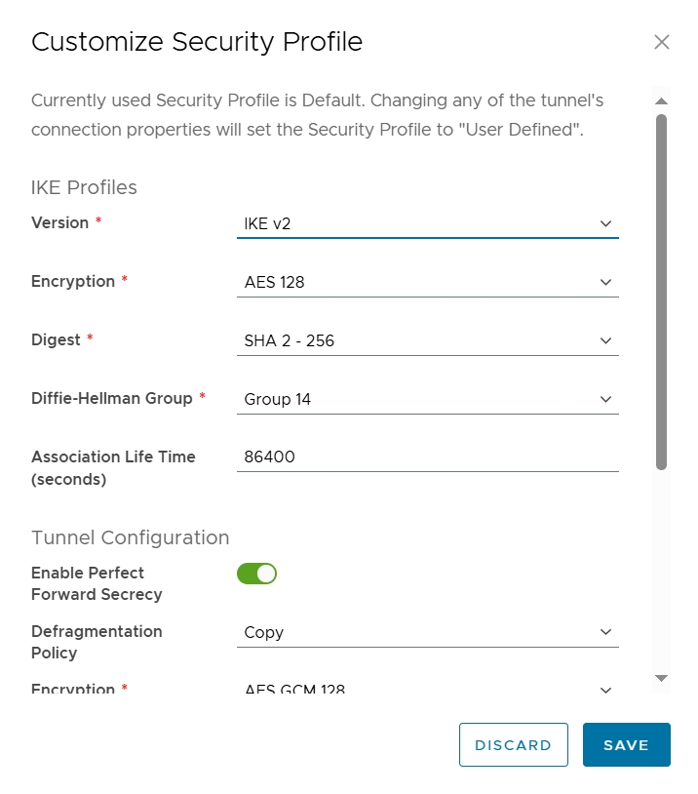

✍ **Check VPN channel status**: select the Statistics tab

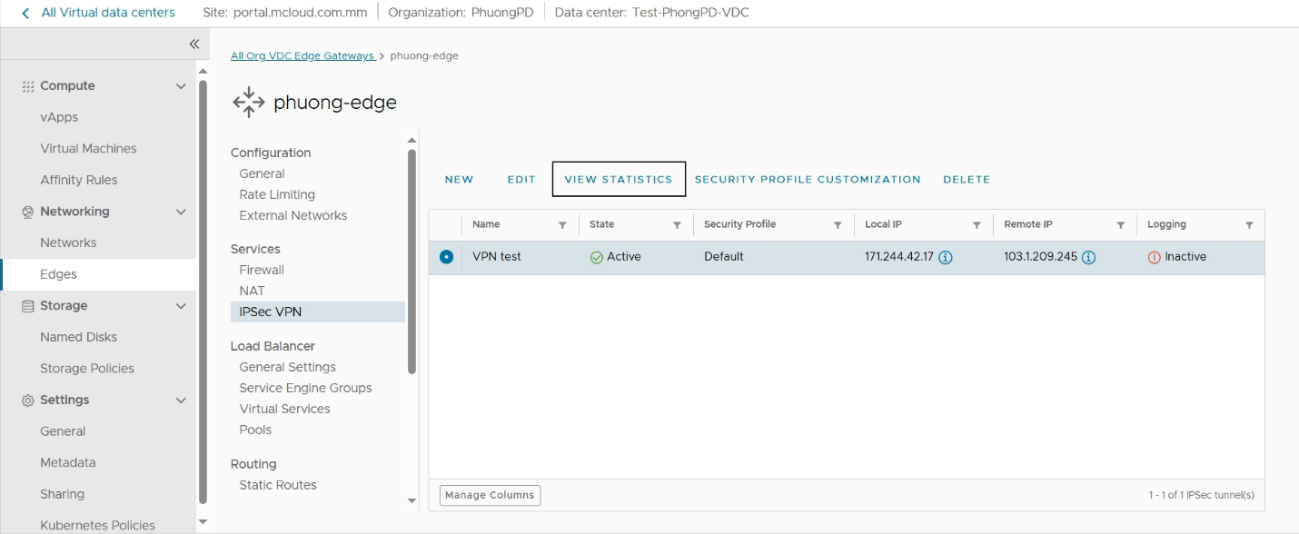

Up to now, we have used the basic features: NAT, Firewall rule and VPN Site to Site mCloud.

## vLoad Balancer Service

With mCloud's vLoad Balancer (vLB) service, you can deploy in model: *transparent mode*.

In the transparent mode model, vLB plays a transparent role with user traffic:

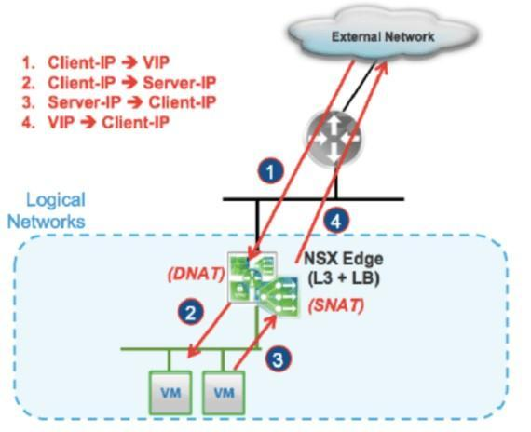

First of all, we need to check state of Load Balancer in Load Balancer-General setting-make sure that state was activated

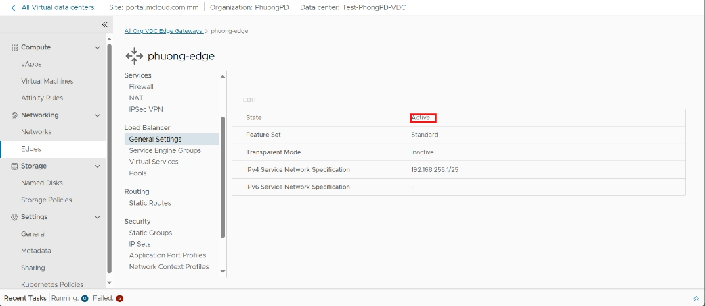

The process of initializing and configuring vLB is carried out through the following steps:

### Application Port Profiles

To create an Application port Profile, select the Load Balancer -> Application Port Profiles tab, click

button **NEW** Parameters to note:

* **Name**: name the Profile
* **Protocol**: protocol type, support TCMPv4, TCMPv6, TCP, UDP
* **Ports**: enter a port

**Select add port profile to add more port profile**

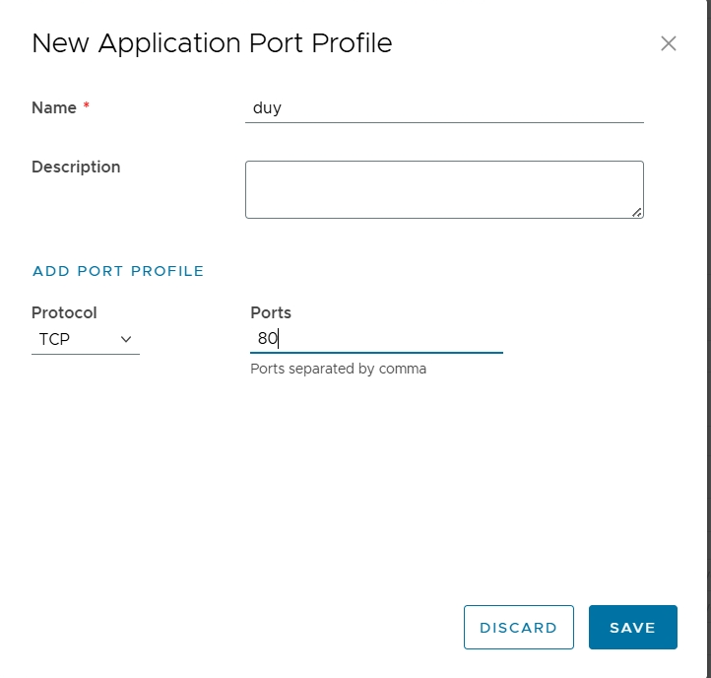

The figure below illustrates creating an Application Profile for 2 HTTP and HTTPS protocols:

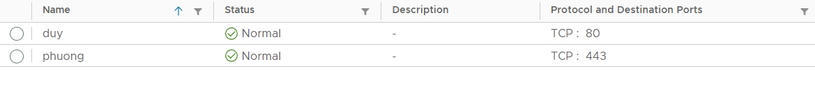

### Server Pool

Select the Load Balancer -> Pools tab, click the **Add** section, enter the following parameters:

* **Name and Description**: enter a name and description for the Pool
* **Algorithm:** Usually use the following 3 algorithms to coordinate traffic to the lower servers:Round robin ,least connection or consistent Hask.
* **Active HealthMonitors:** add Monitor
* **Turn on or off Passive Health Monitor:**enable or disable Passive Health Monitor
* 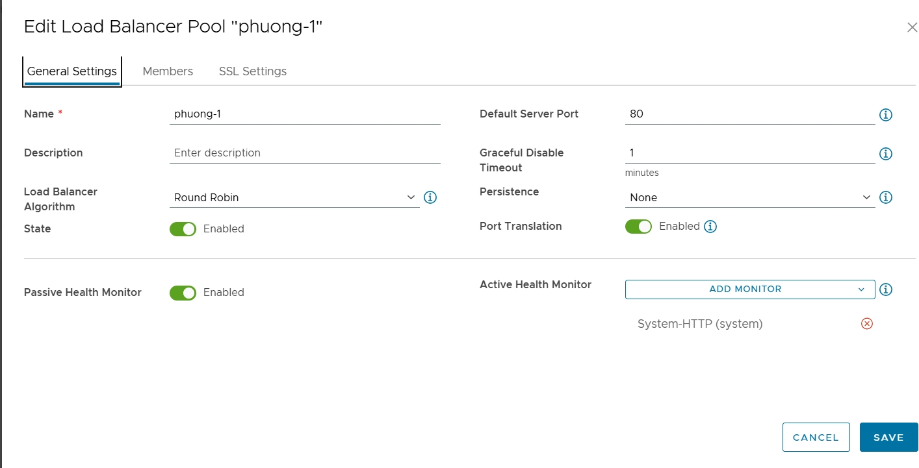

In the Member section, select the **Add** icon and configure the lower Web Servers one by one:

* **IP Address**: the private IP address of the server
* **Port**: corresponding service port, e.g. 80, 443

Click **Save** after entering the parameters.



2 created members are in pool LB_HTTP_POOL:

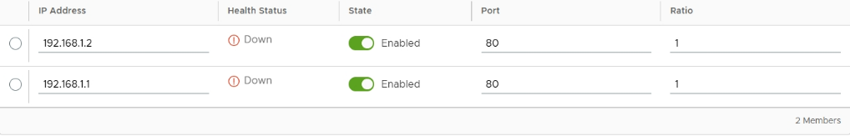

Click **Save** to initialize the server pool.

After initialization, we can check the status of the Pool and the servers in the Pool by clicking **Analytics**

### Virtual Services

This is the final step to setting up the vLoad Balancer. Select the Virtual Services tab, then click **Add.**

The parameters to be set are as follows:

* **Enable Virtual Service:** Enables Virtual Server execution
* **Name**: naming
* **IPv4 Address**: click Select and select the Public Master IP obtained in the instructions above.
* **Service type**: select the protocol and port that listens to the client's connection
* **Load Balanced Pool**: select the Pool created in Step 2.

Press **Save** to save the parameter configuration.

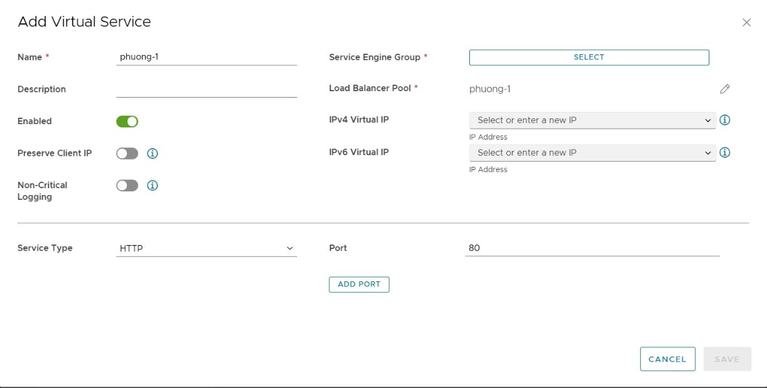

**Note**: now that the basic vLB configuration process is complete, you may need to create a Firewall Rule to allow users to access the Public IP of the Virtual Server created above:

### Test – Service Inspection

Access to the VIP vLB above with Round Robin mode:

1st Access:

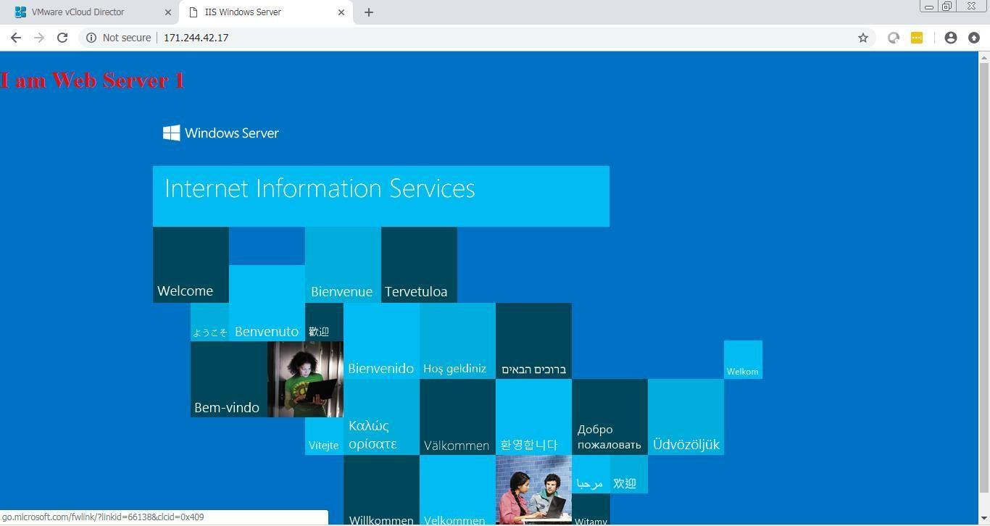

2nd Access: The 2nd Web Server will serve traffic:

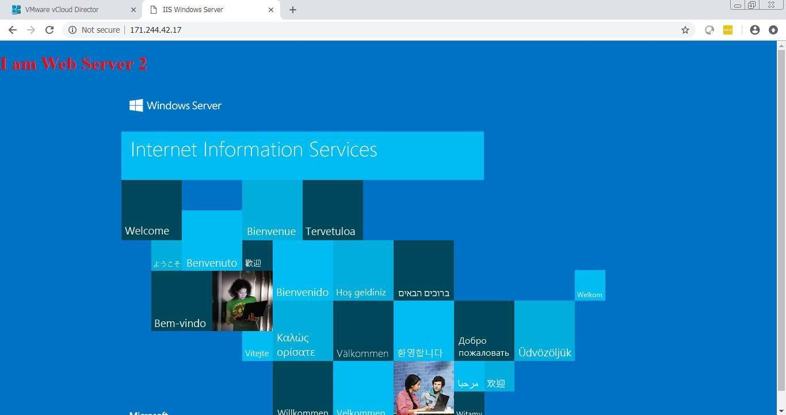

Proceed to simulate disabling the IIS service on Web Server 02:

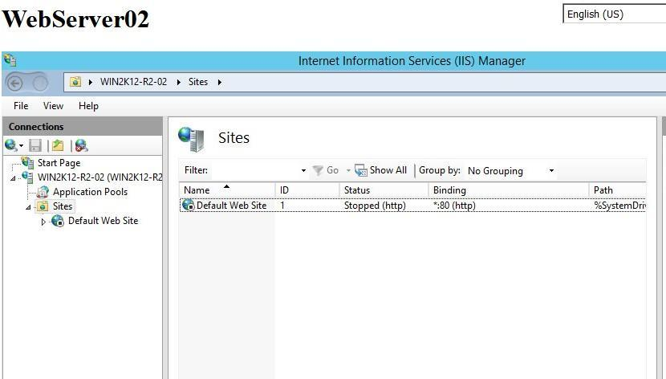

Immediately, vLB recognizes and switches the WebServer 02 status in the pool to down:

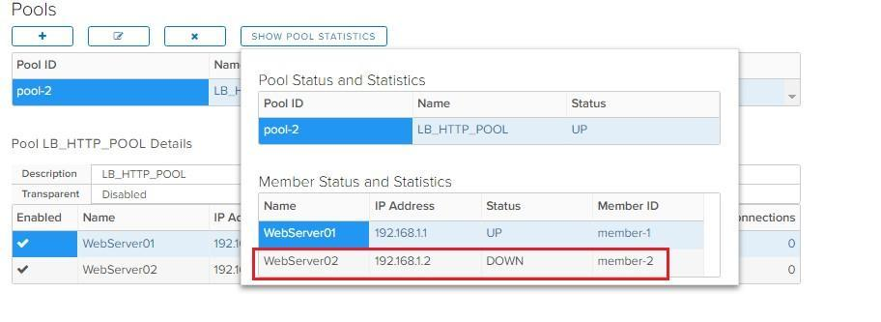

Web Server 01 now acts as the only traffic response for the user:

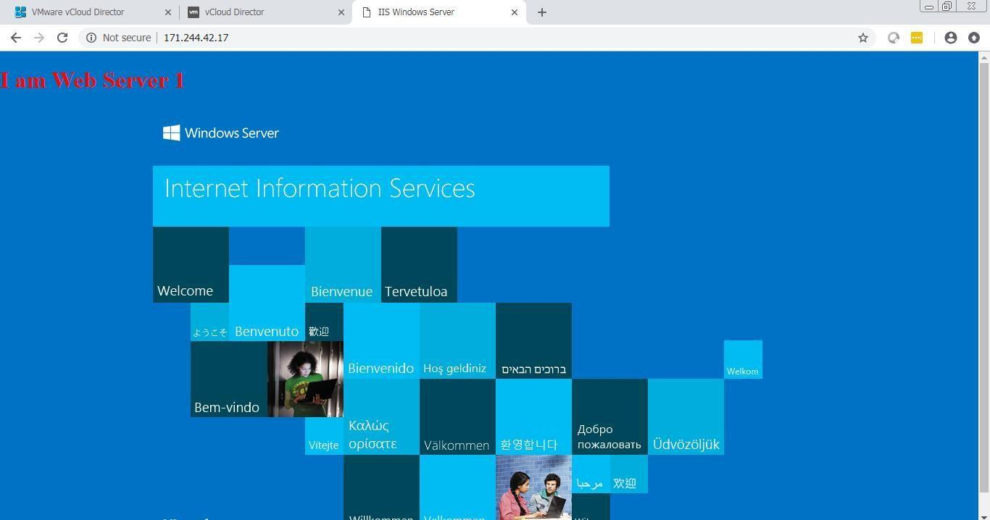

# Information Security

mCloud servers provide customers with guaranteed information security policies and periodically updated with vulnerability patches:

* Install the latest operating system and update the patch. For each version of the Windows Server operating system, an upgrade to the latest service pack is required. (Install security patches only).
* For new systems using the Windows Server operating system, Windows Server 2008 R2 Service Pack 2 or later version is required.
* Set up account policies.
* Delete or disable all unused accounts on the system.
* Set up a strong password policy. (8 characters, with lowercase letters, uppercase letters, special characters).
* Enable soft firewall.
* Set up NTFS-formatted partitions.
* Set up time synchronization for the operating system.
* Time Zone Configuration (UTC+7:00 Bangkok, Hanoi, Jakarta)
* Configure NTP Server (Default is times.windows.com)
* - Enable Remote Desktop, SSH.

# Time-sync server

mCloud servers provide customers with timezone which has been configured and NTP default:

* Time Zone configuration (UTC+7:00 Bangkok, Hanoi, Jakarta).
* Configure NTP Server (Default is times.windows.com).

In addition, mCloud provides customers with NTP servers as follows:

* NTP Server 01:

# Software piracy

Software copyright is stipulated in the contract signed with the customer. When customers have requests or questions about copyright, please contact the hotline:

1800888939 and 02444553333 .Access https://mcloud.com.mm to send support ticket or live chat with us (24/7).